

COURSE NAME: TBANLT 510 A Business Analytics

QUARTER: Autumn 2018

VERTICAL INDUSTRY: Federal Government

BUSINESS PROCESS: Department of Transportation

U.S. TRAFFIC FATALITY ANALYSIS

- TABLEAU TUTORIAL

I certify that I have completed this assignment within the Academic Integrity guidelines presented in the UW General Catalog. Further, I certify that I do not have any knowledge of any other individual(s) violating these guidelines.

Sonam Misra

[Sm0601@uw.edu](mailto:Sm0601@uw.edu)

03-Dec-2019

Table of Contents

1. EXECUTIVE SUMMARY: 2

2. BACKGROUND: 3

3. LEARNING OBJECTIVE: 3

4. METHODS & DESCRIPTION OF DATA: 3

5. DATA PREP: 4

6. DELIVERABLE 1 - DASHBOARD: 5

6.1. Scenario: 5

6.2. Purposes/Questions/Application: 6

6.3. Procedure – Dashboard 7

7. DELIVERABLE 2 - STORYBOARD: 33

7.1. Scenario: 33

7.2. Purposes/Questions/Application: 34

7.3. Procedure – Storyboard 35

8. Results/Insights/Conclusions: 54

8.1. Results/Insights/Conclusions (Dashboard): 54

8.2. Results/Insights/Conclusions (Storyboard): 57

8.3. Innovative Solution: 58

9. Learning Objectives (Measure): 58

10. Limitations: 60

11. References . 60

1. EXECUTIVE SUMMARY:

The following report provides a step by step guide to analyze the U.S. traffic fatality crashes happened in the year 2015-2016. The purpose of this tutorial is to strengthen the problem solving and analytical skills of the user using Tableau Desktop. The tutorial will provide the user with detailed explanations of different features and functionality of Tableau and how it can be used to explore the research question. The user will gain insights about the data provided by nhtsa (National Highway Traffic Safety Administration) and skills to present the findings in a visually interactive way. The user will be able to explore the data using descriptive and diagnostic analytics. This tutorial will enable the user to solve business problem using the 5W’s (Why, What, When, Where, Why) based on the research question.

Included in this tutorial are the following high-level considerations:

* **Background:** This sectionprovides the details of the purpose of this analysis. The background of the research question is defined in this section.
* **Data Description:** This section briefly describes the nhtsa dataset and the data source where it is found.
* **Data Prep:** This section will provide the steps required to clean the data according to the research questions. In this section user can learn the process to clean data in BigQuery.
* **Tableau Dashboard Tutorial:** This section provides step by step instructions on how data can be analyzed, manipulated and presented in a visually interactive style. This is a detailed section with steps along with the snapshots of each step.
* **Tableau Storyboard:** This section provides step by step instructions on how deep dive analysis of a scenario can be done to investigate the issues and present the findings with a storyline. This is a detailed section with steps along with the snapshots of each step.
* **Publishing to Tableau Public:** This part will provide the steps to publish the storyboard and dashboard to tableau public website so that it can be easily shared and accessed.

On completion of this tutorial the user will gain insights of the traffic fatality data, problems and current situation. The user will be able to summarize the findings and present it to the business through dashboards and storyboard. The user can test the leaning by measuring the knowledge gained with learning objectives provided in the tutorial. The user can apply the skills learnt in this tutorial in different real word scenarios .

1. BACKGROUND:

Road Accidents is a serious problem in United Sates resulting in injuries, fatalities and economic loss. The research question of this tutorial is to find out the factors that causes road fatalities in U.S. This research is initiated by the U.S. department of Transportation. The reason they want to conduct this research is to evaluate the effectiveness of current safety programs.

The aim of the department is to understand the problem in-depth and analyze the research findings. This analysis will enable the department to better strategize, plan and implement safety programs.

The department needs an interactive report on the findings of last two-year (2015-2016) fatality crashes happened in U.S. It is important for the department to understand the characteristics of the past crashes which includes the environmental factors, trafficways, Collison nature and impairment due to alcohol.

The department wants their business intelligence team to display the findings using an interactive data visualization tool. These interactive visualizations based on Tableau dashboard and storyboard will be presented to their security teams. The goal is to make everyone understand the findings quickly.

1. LEARNING OBJECTIVE:

The purpose of this tutorial is to strengthen the problem solving and analytical skills using Tableau Desktop. The tutorial will provide the user with detailed explanations of different features and functionality of Tableau and how it can be used to explore the research question. The user will gain insights about the data provided by nhtsa (National Highway Traffic Safety Administration) and skills to present the findings in a visually interactive way. Below are the five-learning objective of this tutorial:

* Able to find out total number of fatalities in each state.
* Understand the characteristics of environmental factors, trafficways, Collison nature and impairment due to alcohol and their impact on traffic fatalities.
* Identify the relationships, outliers and trends present in the data.
* Present the insights in an optimal and engaging way.

1. METHODS & DESCRIPTION OF DATA:

**Dataset Description**: This dataset was provided by National Highway Traffic Safety Administration. This dataset contains detailed information about fatal traffic crashes within the 50 states, the district of Columbia and Puerto Rico for the year 2015 & 2016 in two separate files. The dataset contains the details of all those crashes which are associated with motor vehicles and caused deaths of either driver/occupants or non-occupants within 30 days of crash. The original dataset contains 70 columns which details the factors behind traffic fatalities across the US. There is one record for each accident with a unique accident id. It contains the information about the environment, trafficway, manner of collision, timestamp of crash, person involved in the crash and contributing factors like alcohol, etc. These details can be used to identify the driving patterns, climate conditions and behavioral factors like drunk driving that impacts these fatal crashes. Below attachment provides the column names and their datatype -



**Source of dataset and steps to retrieve the dataset**: This is a Big Query dataset and can be accessed from Tableau by setting up a connection to Google Big Query. To access the data below steps, need to be performed:

* Access to Google cloud using following link using google credentials <https://cloud.google.com>
* From google cloud console, big query dashboard can be accessed.
* nhtsa dataset is available under public data set. (Datasetid: bigquery-public-data:nhtsa_traffic_fatalities)

1. DATA PREP:

Data Prep is performed in Google Big Query. Below steps are performed as part of Data Prep for nhtsa dataset:

* **Adjusted the sample size:** To increase the sample size, two-year data is merged. A view is created to merge two datasets which has data for years 2015 and 2016 as shown below: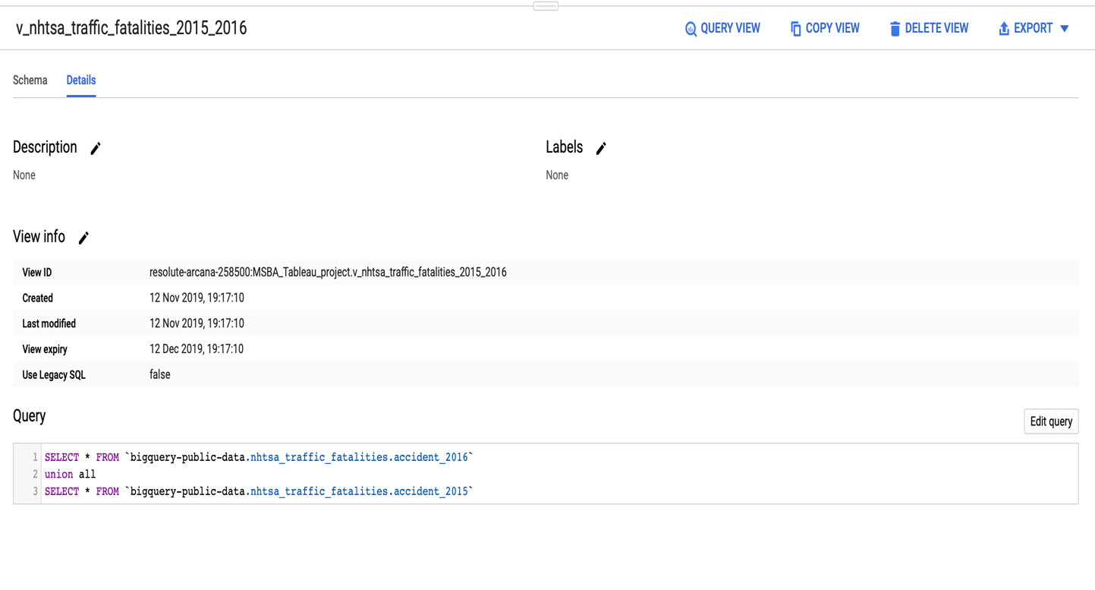
* **Removed unnecessary fields**: Another View is created to select the relevant columns needed for the research question as shown below

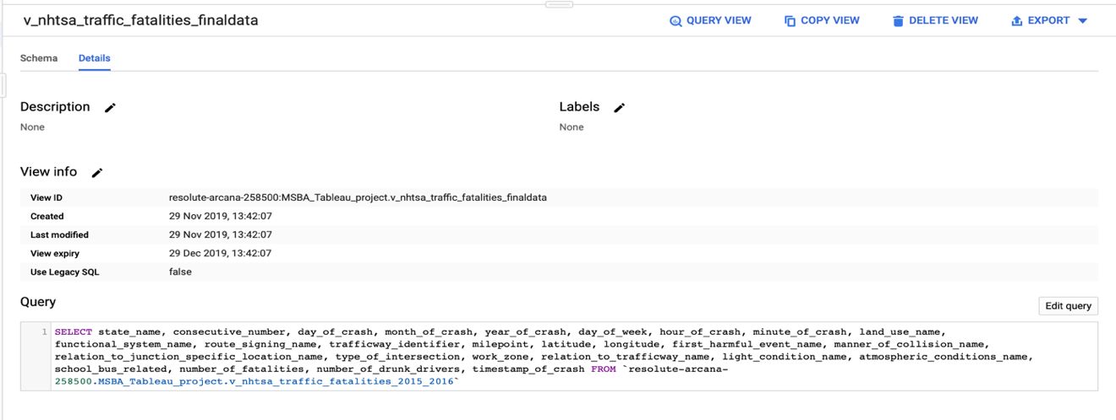Out of 70 columns, 27 columns are selected. Most of the columns which are not chosen were related to the unique ids of the selected columns and rest were not related to the research question.

1. DELIVERABLE 1 - DASHBOARD:

An interactive dashboard is created by the business Intelligence team to help the U.S department of transportation to analyze the road safety issue. The aim of this dashboard is to present the issue and statistics in a way that can help the department to understand key problems and work on their strategies to improve the road safety. The dashboard created for this purpose has the below KPIs:

* Total number of accidents happened across the country in past two year (2015-2016)
* Total number of people died in these road crashes
* What is the fatality count across each state in the country?
* Total number of fatalities each month

This dashboard is published to Tableau public so that it can be easily accessible.

**Dashboard Link:**

<https://public.tableau.com/views/Tutorial_Dashboard_RoadFatality/TutorialDashboard1?:display_count=y&publish=yes&:origin=viz_share_link>

* 1. Scenario:

The U.S department of Transportations is organizing the annual seminar on the road safety to guide the people about the safety measures to be taken while driving on the high-risk prone routes. They will announce the new decisions which the government is going to make to improve the current situation. They will also explain the leading factors behind road fatalities. The ultimate goal will be to identify the factors that causes the accidents and help to reduce the deaths, injuries and other losses resulting from these accidents. The presenter in this seminar want to briefly demonstrate the factors influencing traffic fatalities in the United States. The demonstration should be able to show the understanding of Road fatalities and determine leading causes.

You work for the department as a member of business Intelligence research team. Your job is to analyze the data and evaluate the trend and relationship between the factors and road deaths. You are in the year 2017 and need to evaluate the data for past two years. You want to present your understanding by a visual representation i.e. Tableau Dashboard which will clearly summarize the various factors that causes road fatalities in the U.S. The dashboard should be interactive and easy to understand at first glance. This dashboard will be presented to the Transportation staff members as well as the general public in the seminar.

* 1. Purposes/Questions/Application:

**Purpose**:

Road Crashes is a serious problem in United States resulting in a large death toll. Motor vehicle travel is the most popular mean of transportation. Unfortunately, motor vehicles are the leading cause of road accidents as well. To improve this situation, The U.S department of Transportation wants to educate people about road safety. They want to guide the people about the environmental factors, threat of drunk driving, high-risk prone highways and t-points. This will help people to better plan their trip and avoid road accidents. This knowledge will help the people to improve their driving skills and take safety measures while on road.

To provide these safety measures, in-depth understanding of the past accidents is required. The research team needs to understand what caused these accidents in past. Evaluation of each accident case is needed. The research department needs to conduct research to study unsafe behaviors of drivers, environmental factors and locations which are at higher risk of fatal crashes. For that purpose, descriptive and diagnostic analytics needs to be performed.

**Questions**:

They need to answer the following question so that a clear picture of the problem can be formed, and real issues can be highlighted.

* What were the main factors that influenced the road accidents?
* What was the total number of accidents and total number of people who died?
* What is fatality count for each state?
* How climate change impact the risk of fatal crashes?
* Which month of the year had maximum incidents?
* What time of the day had maximum incidents?

**Application**:

The outcome of these research questions can be very helpful to focus on the real issues. On the basis of these findings department can reevaluate their current strategies and set their priorities. They will make the decisions to change their policies. The department will make the following decisions-

* Do they need to hire more officers to improve the security?
* Does the department need to provide new trainings to their security team to cope up with the current situation?
* What changes need to be made in the strategies?
* Do they need to update their public safety manuals?
* Do some locations need more security force than others?
* Do they need to take care of road conditions or road structure to avoid accidents?
* Do some weekdays need more service force than other days?
* Do they need better methods to identify drunk drivers?
  1. Procedure – Dashboard

The following tutorial will guide you how to build an interactive dashboard. The dashboard will provide the factors that influence the road accidents in U.S at a glance. The prerequisite for this tutorial is basic understanding of SQL, Tableau Desktop installed and problem-solving skills.

Perform the below steps to build an interactive dashboard:

**Import Data:**

This step is performed after you find the dataset. The dataset is available under public datasets in Google Big Query. This dataset can be cleaned and prep in Big Query as illustrated above in Data prep section. To connect the data source to tableau, follow these steps:

* Open Tableau and click on add a connection and select Google BigQuery.

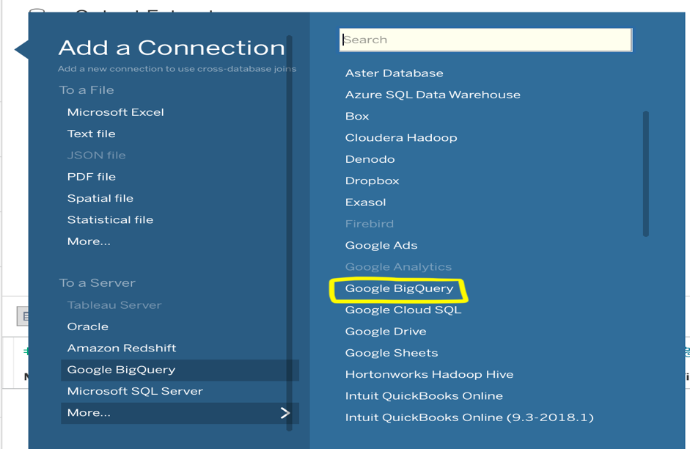

* Connect to the view created in Google Big Query for the final dataset and extract the data.

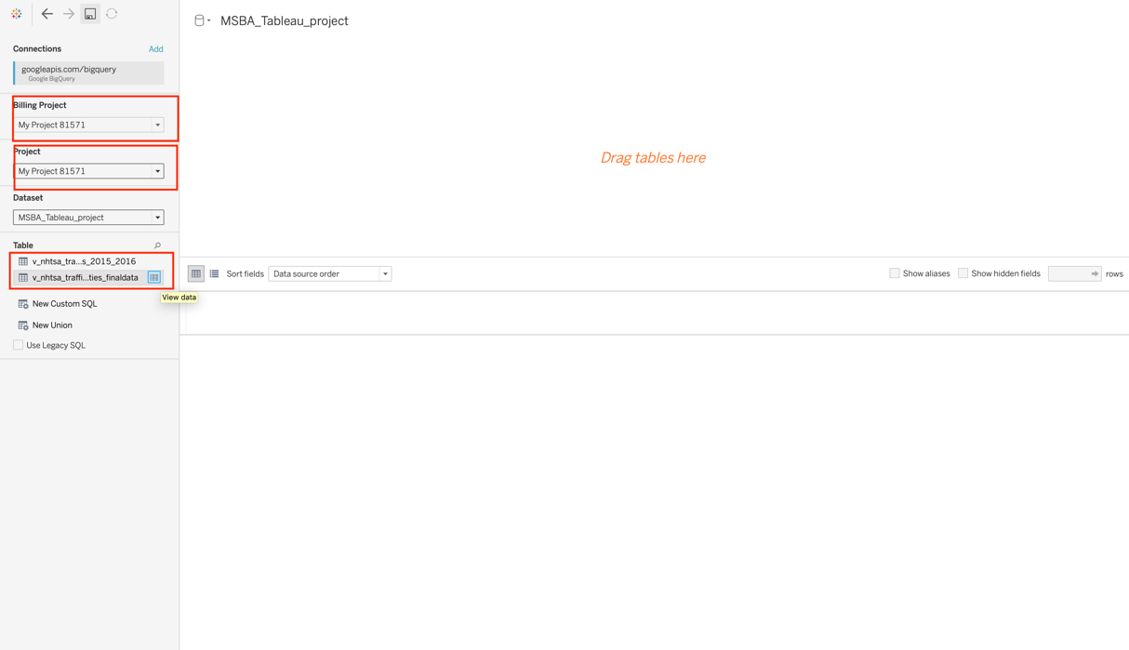

* Extract the data as below. On the right top corner, select the Extract option provided under connection. Do avoid the cost associated with multiple query hits on google big query we will extract the data and it will also improve the performance.

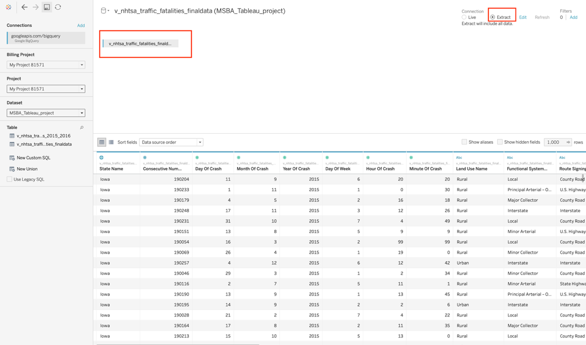

**Create Worksheets:**

Once you have uploaded the data, data is ready to be explored. Dashboard is the consolidated view of worksheets. So, to create a dashboard, you need to start building up the worksheets first.

**Worksheet 1**: Fatality Count by State

**Purpose:**

To analyze each state fatality count you need to perform the following steps. Once you present the fatality count it will be easier to identify high risk prone states. The department can easily identify risk areas and can make their strategies accordingly.

**Steps:**

* Create a blank worksheet by clicking on the highlighted icon as shown below.

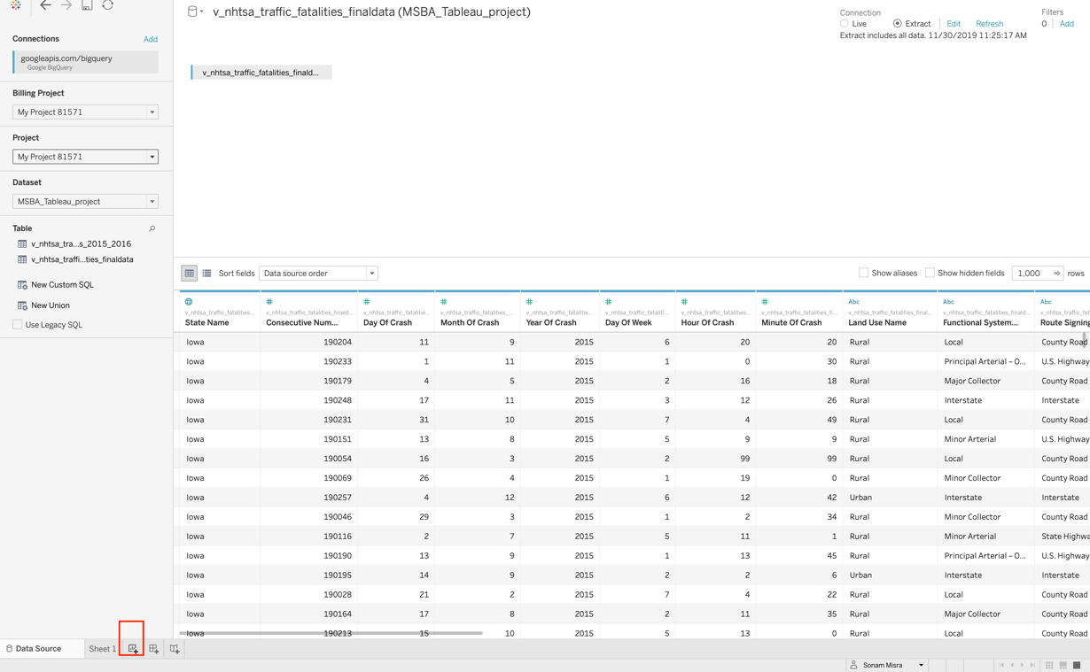

* In first worksheet we are going to explore fatality count by state. Before that rename the worksheet to an appropriate title.

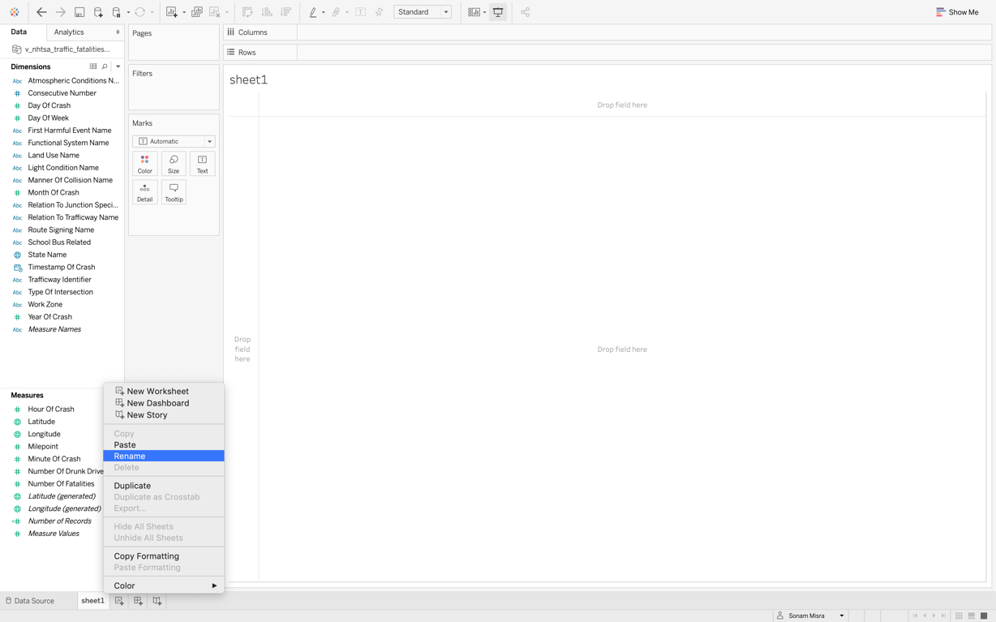

* On the left side you will see the dimension and measure section. Drag the “State Name” from the dimension section to the “Rows”.

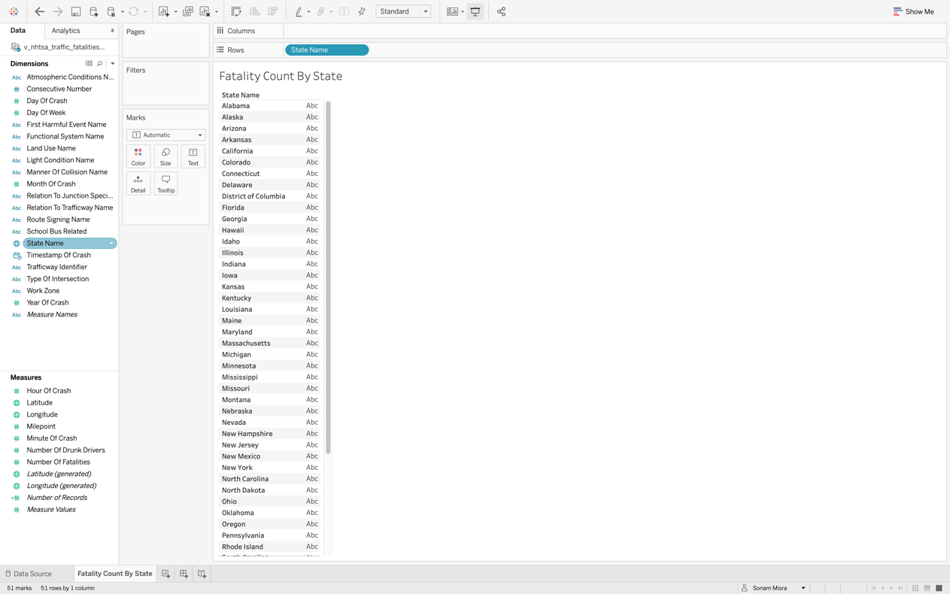

* Drag the “Number of Fatalities” from the “Measures” section to the “Columns”

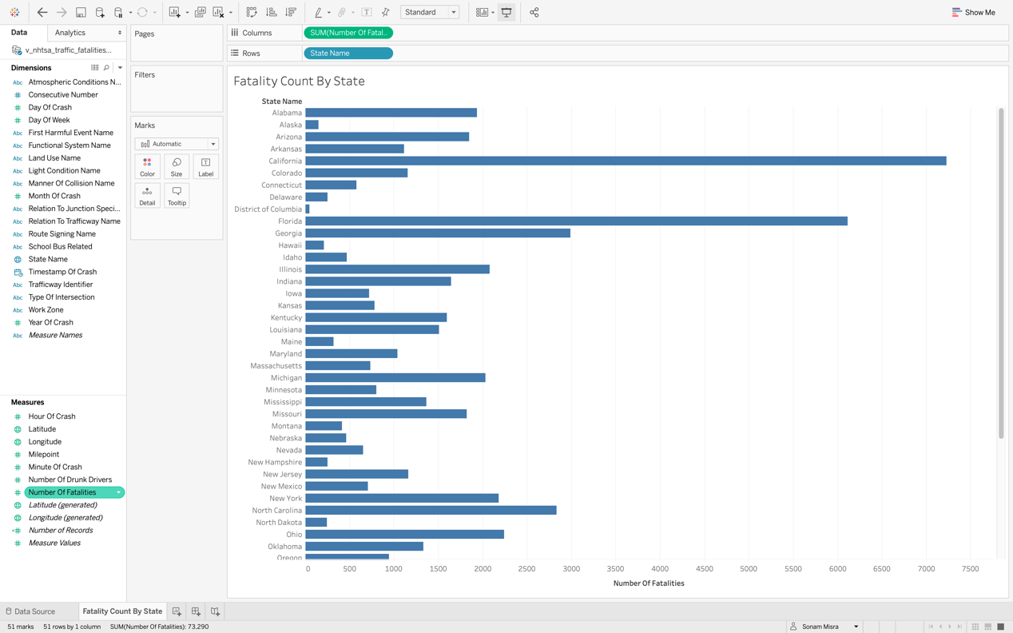

* Change the measure type from Sum to Percent of Total by using a quick table calculation.

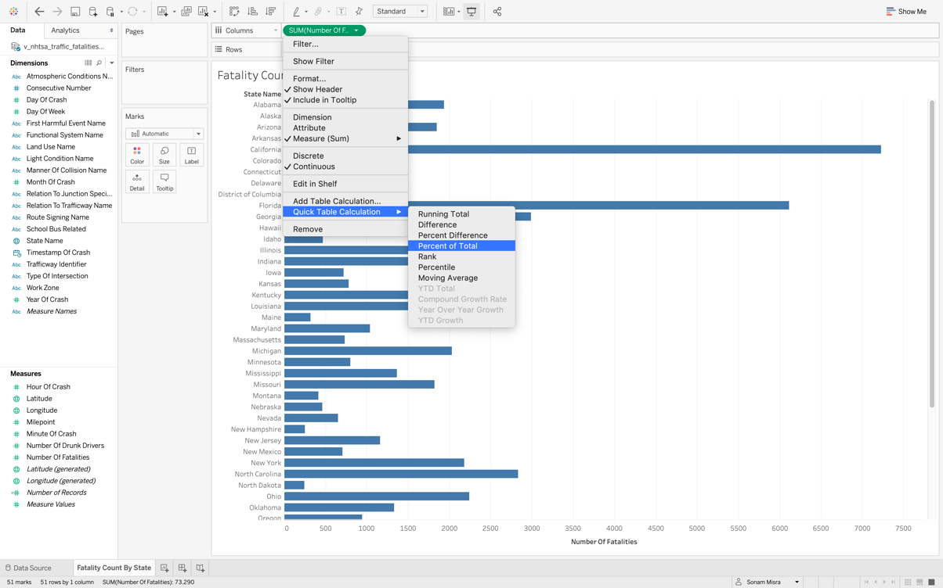

* Change the display visualization by clicking on “Show Me” in the top right corner.

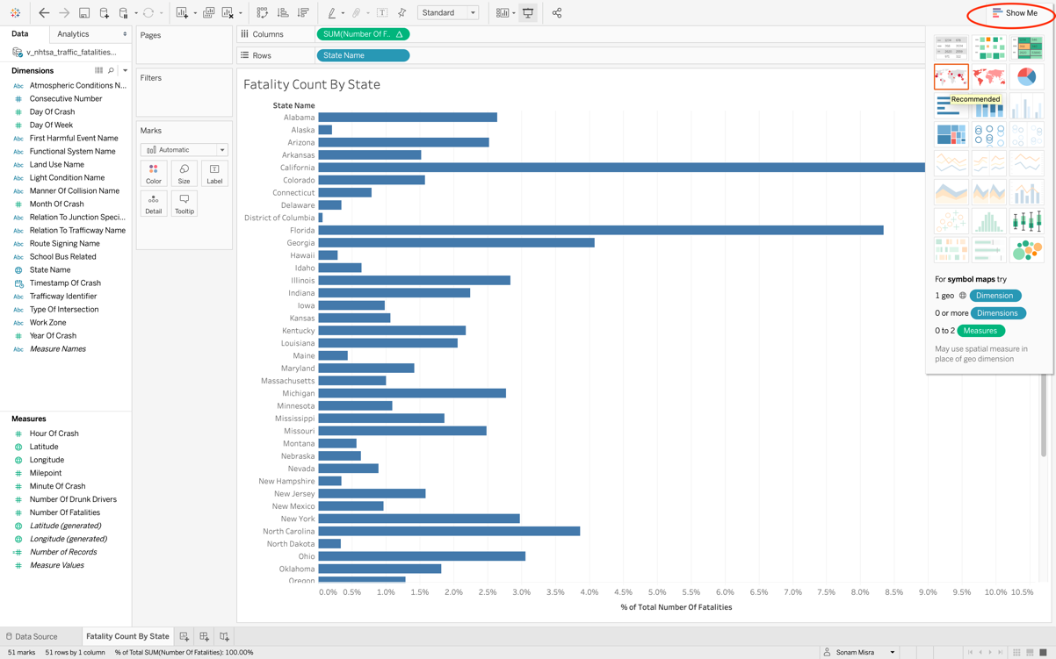

* Drag the State Name from the Dimension section and drop it to the Color box under Marks. This step will represent each state with a different color.

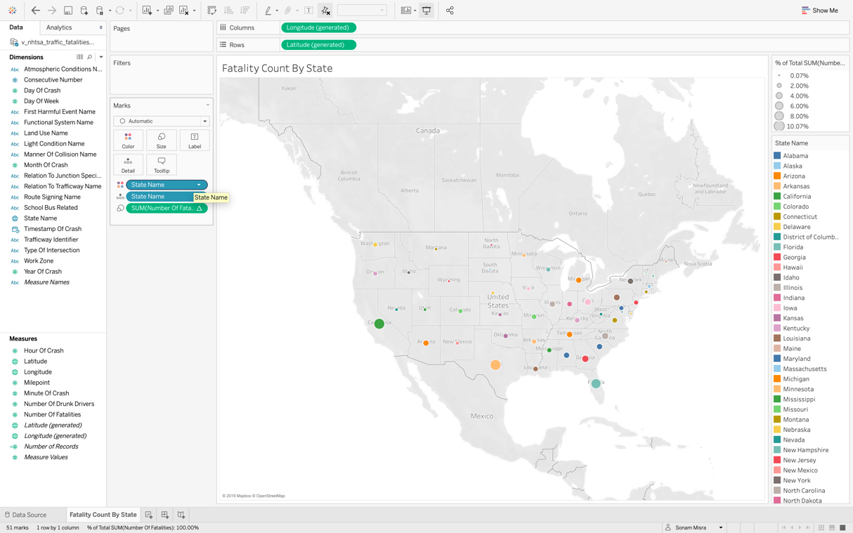

**Worksheet** **2**: Fatality Count by Month and State Name

**Purpose:**

To analyze the fatality count of each state we need to perform the following steps. Each state has different weather, climate and roads which will impact the fatality rate. Let’s explore each state’s fatality count.

**Steps:**

* Create a new worksheet by clicking on the new worksheet icon present at the bottom left -> Rename the worksheet to appropriate title as mentioned in the previous step.
* Drag the “Month of Crash” from dimension pane to the columns in the center.

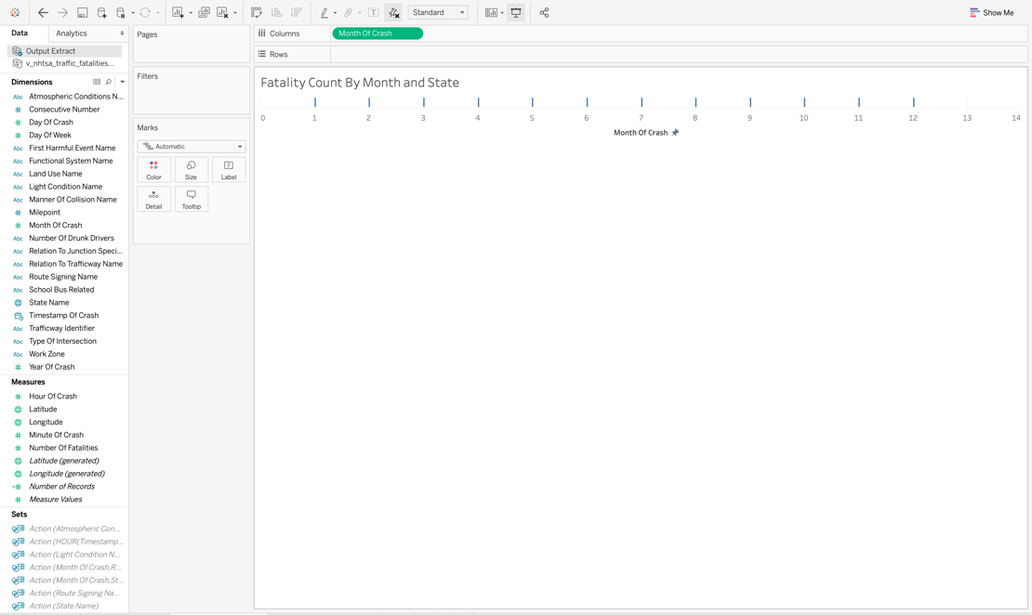

* Edit the axis of month of axis. We will consider axis range from 1 to 12 to make it suitable for month analysis.

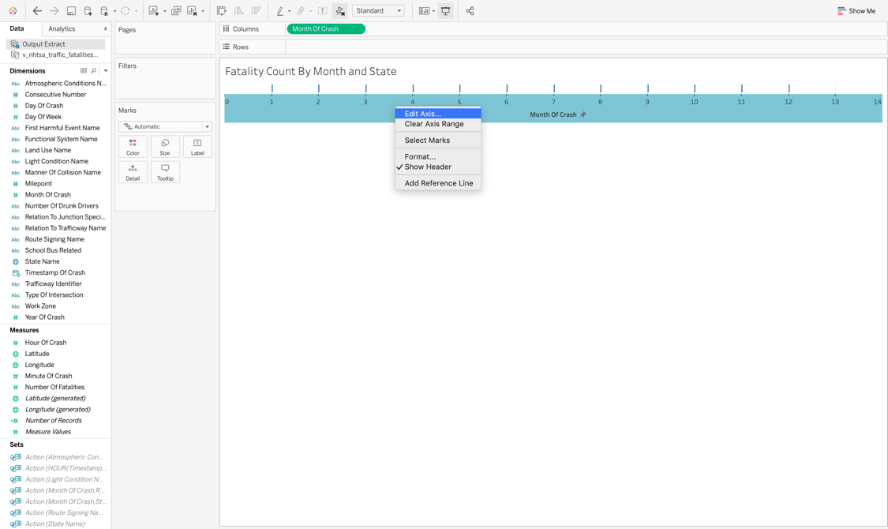

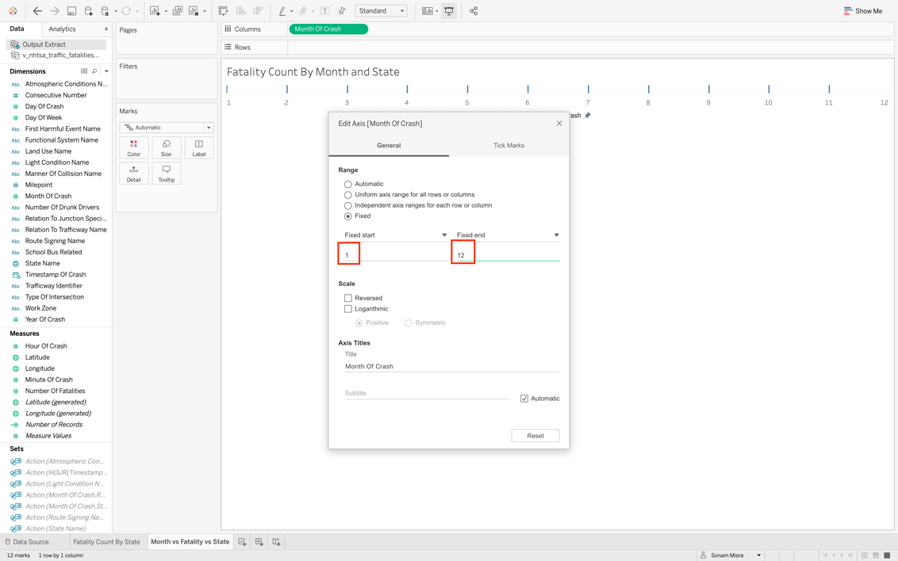

* Drag the Number of Fatalities from measures and change it to percent of total.

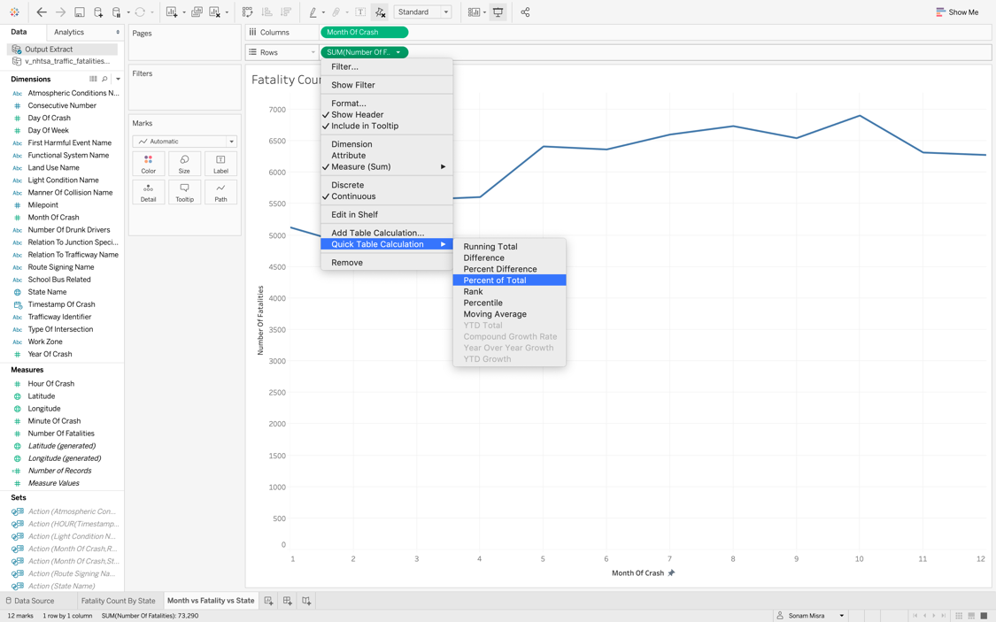

* Drag and drop the State Name from dimension to the filter, color and label. Each state will be represented by a different color name. The state name filter on the right will enable the user to select one or more than one state for analysis purpose.

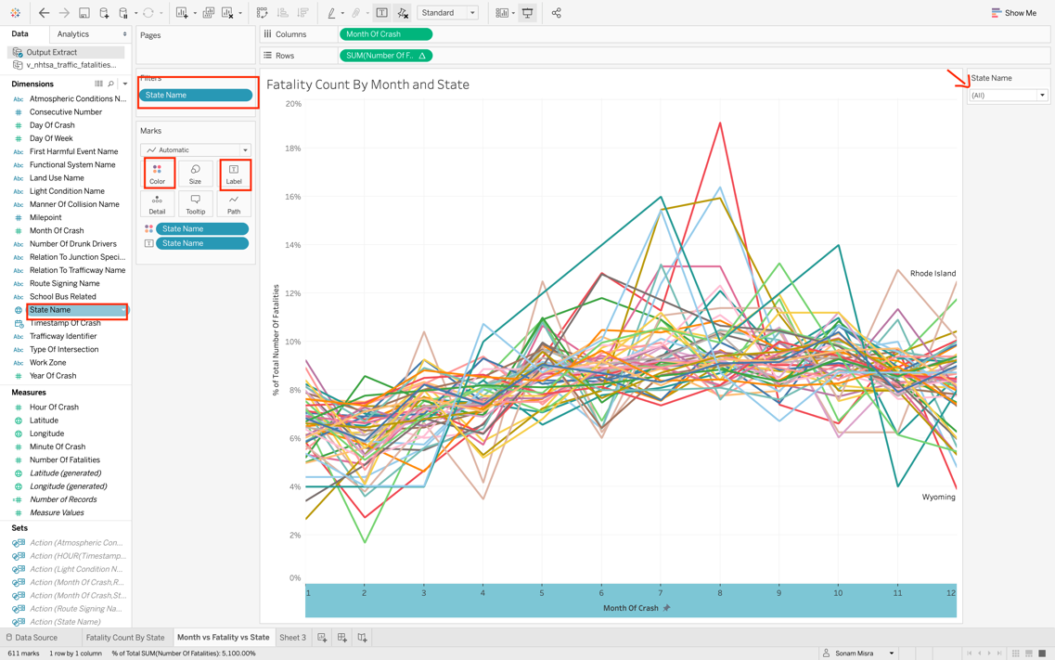

**Worksheet** 3: Atmospheric Conditions vs Fatality Count

**Purpose**:

To analyze the impact of weather on road accident we will explore the atmospheric condition. Weather is an important factor while driving on roads. Let’s explore if it impacts the fatality count or not. Below steps need to be performed.

**Steps**:

* Start with a blank worksheet -> Rename the worksheet to appropriate name. Drag the atmospheric condition from dimensions to the columns.

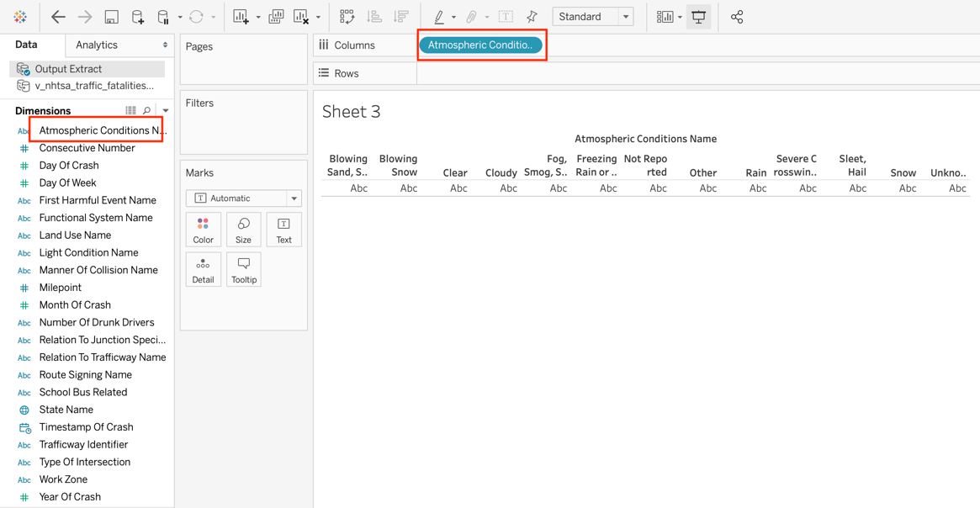

* Drag the number of fatalities from measures to rows -> Add a quick table calculation as describer earlier and change it to percent of table and then click on “Show me” to change the visualization.

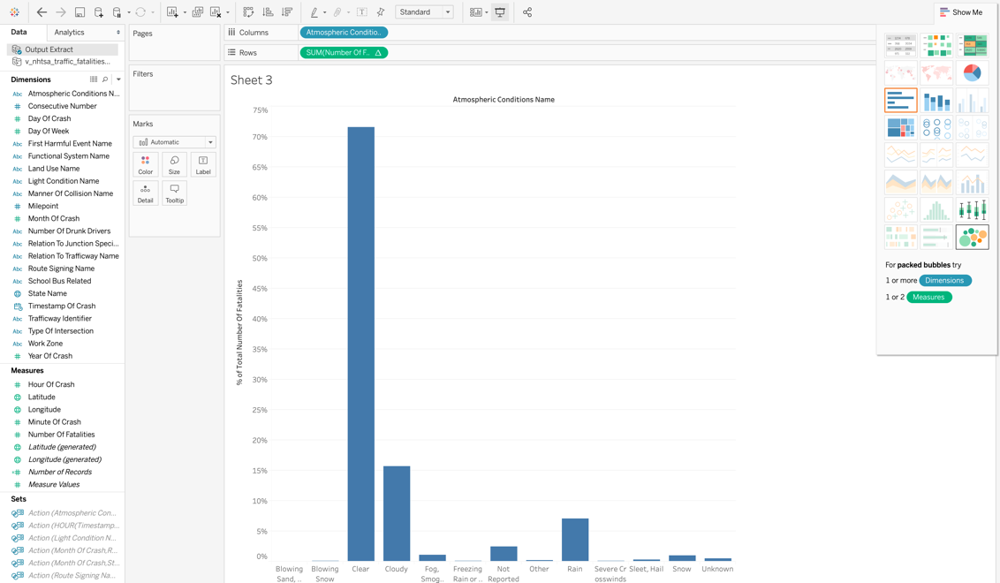

* Next drag the number of fatalities to label so that it can be visible in the visualization graph.

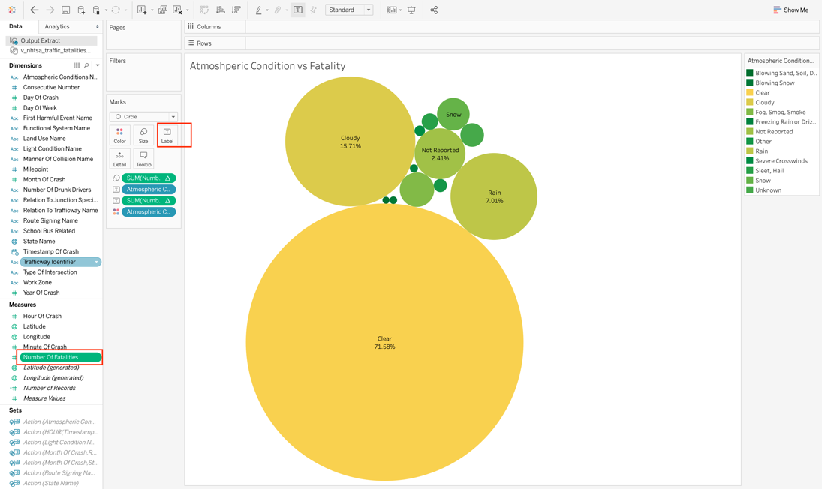

**Worksheet** 4: Light Conditions vs Fatality Count

**Purpose**:

Light condition plays an important role while driving on the road. Generally, it’s convenient to drive during daytime than the nighttime. We need to explore this hypothesis with the data we have. To analyze the impact of light condition on traffic fatality we will perform the following steps.

**Steps**:

* Create a new worksheet -> Rename the worksheet -> Drag the light condition from dimensions to the columns in the center as shown below.

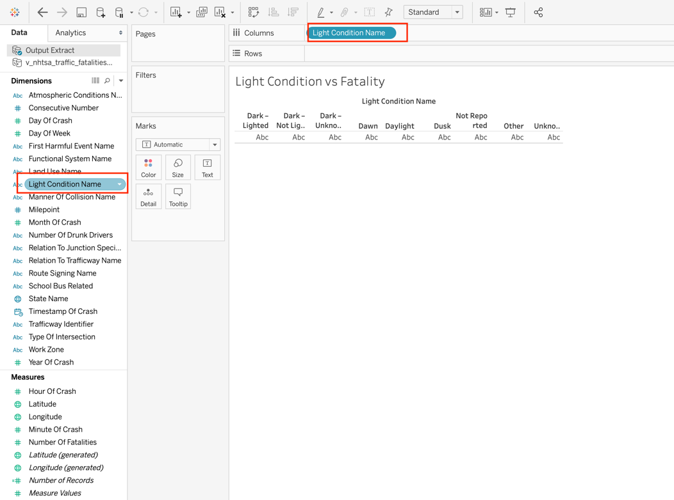

* Drag the number of fatalities from measures to the rows -> Add a quick table calculation and change it percent of total.

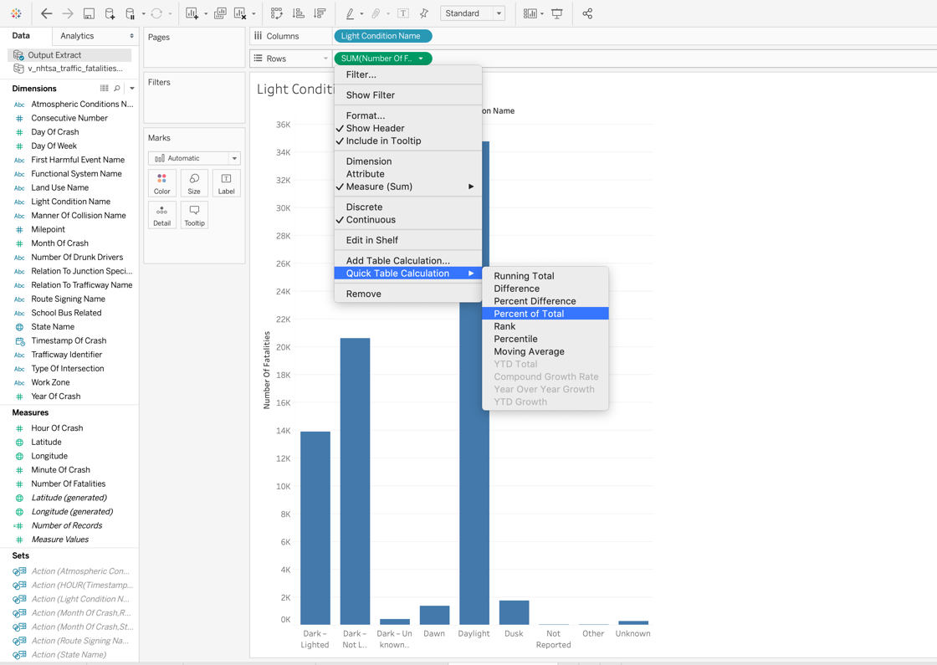

* Change the visualization to pie chart. Click on show me in top right corner and choose the visualization.

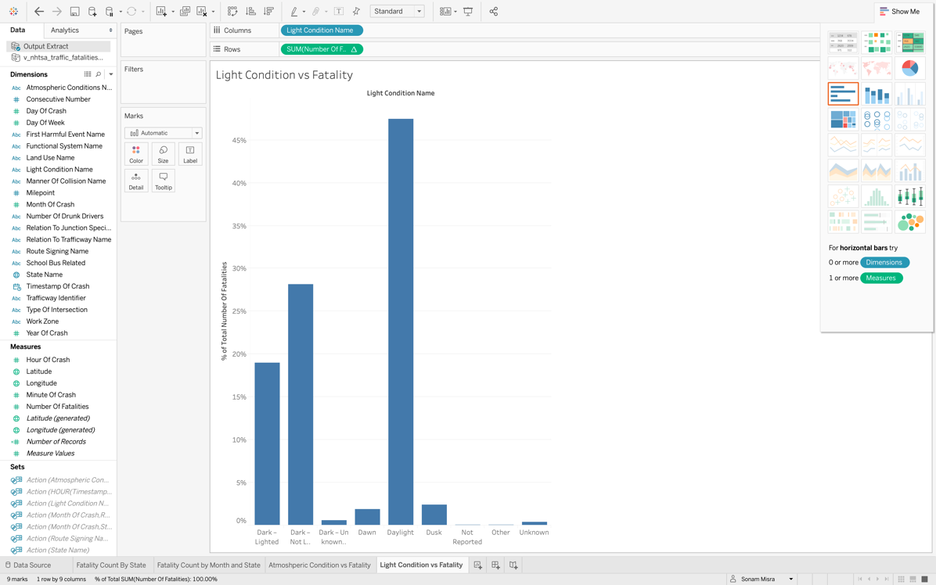

* Adjust the size of the pie chart by clicking on size under the marks.

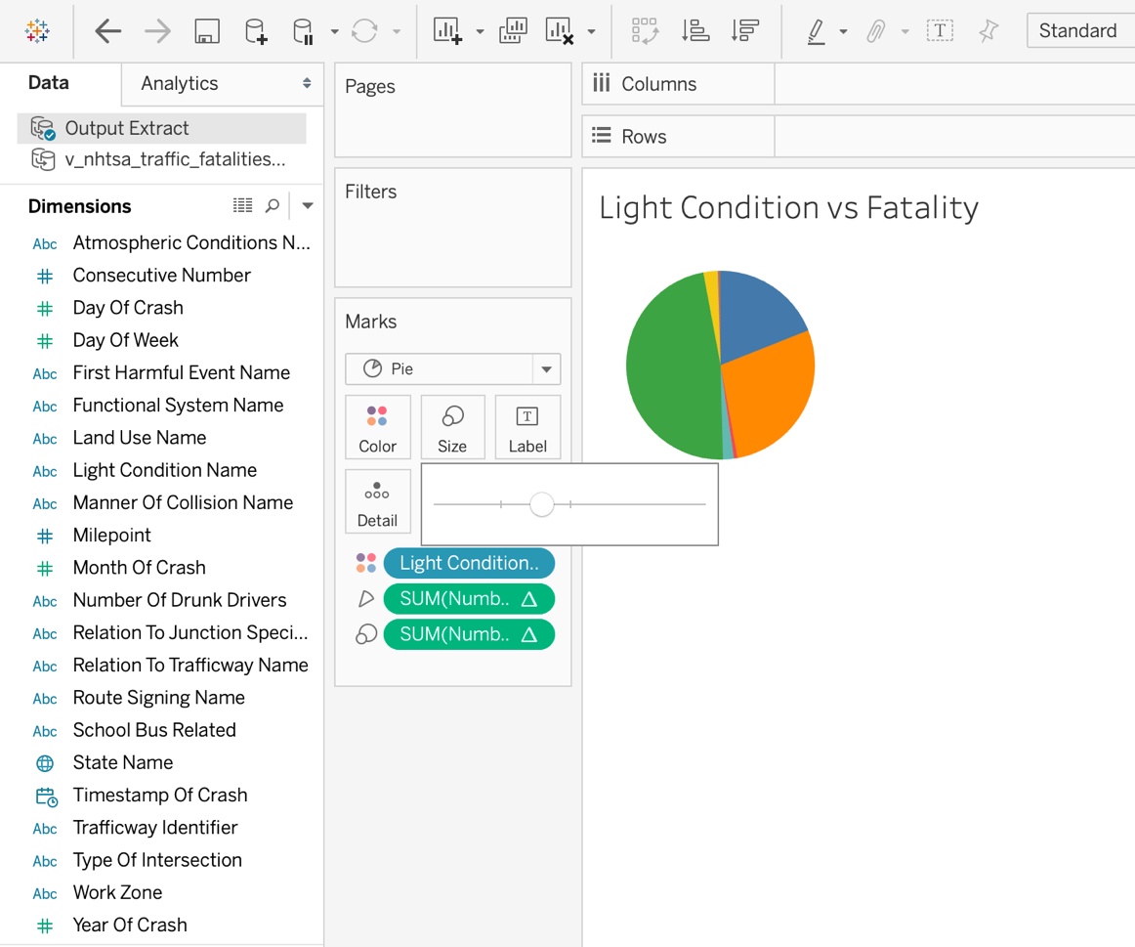

* Drag and drop number of fatalities from measures to the label under marks and change it to percent of total.

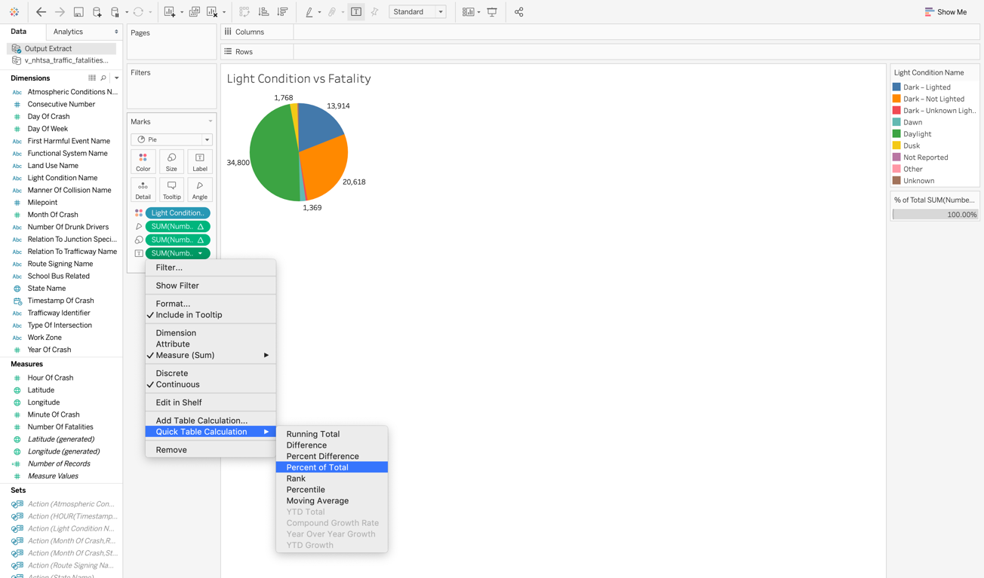

* Final chart will look like below.

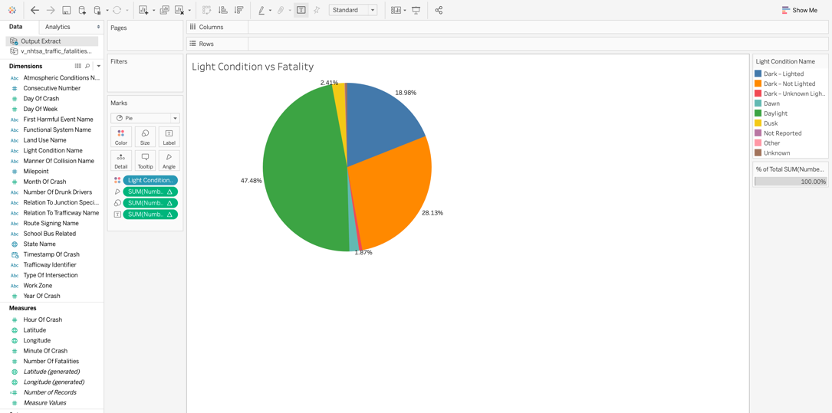

**Worksheet** 5: Fatality count by Land Name

**Purpose:**

To compare the fatality count between rural and urban areas in U.S we will perform the following steps. We have a hypothesis that since the population for rural area is less than urban the fatality count should be less. Let’s perform the below steps and verify if the hypothesis is correct.

**Steps:**

* Create a new worksheet -> rename to the appropriate tile.
* To create a donut chart, we need to drag number of records from measure and drop it to the row. Perform the same step one more time.

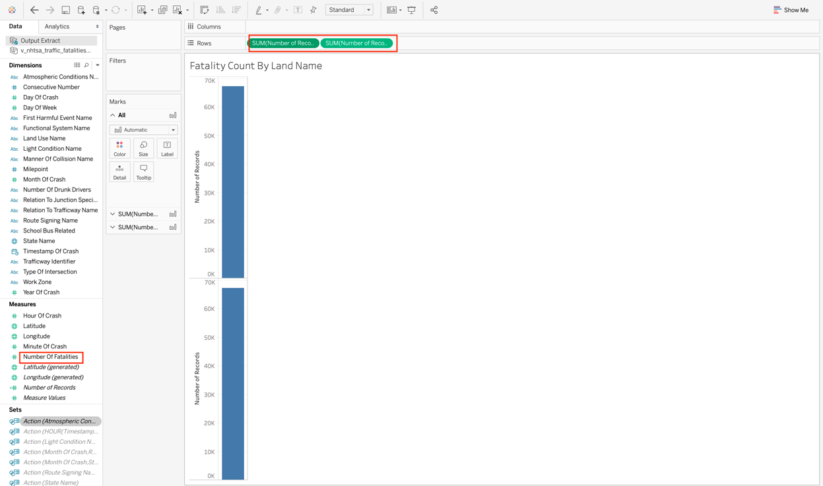

* Change the measure to minimum as show below.

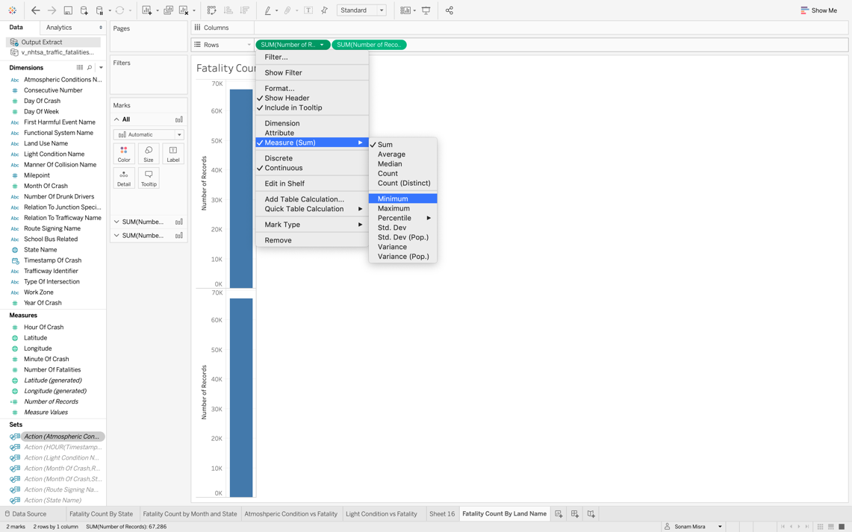

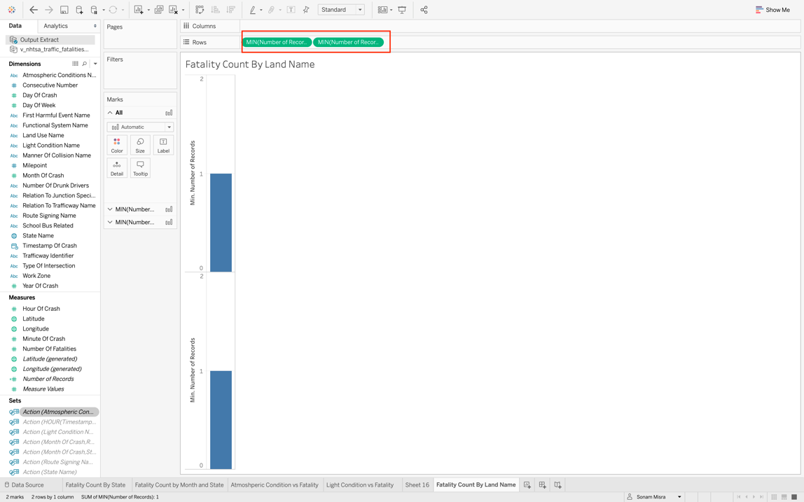

* Under the mark section, click on the drop down and select pie chart.

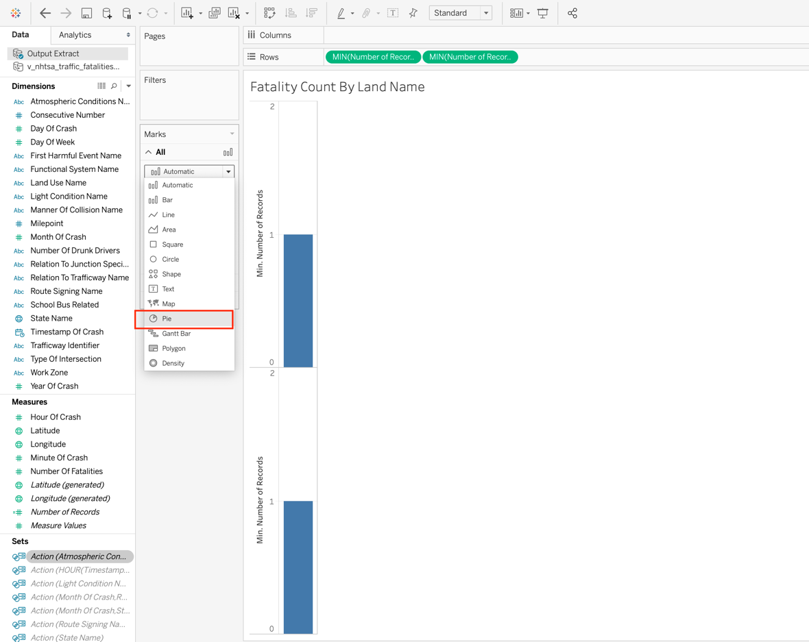

* Right click on number of records and select dual axis.

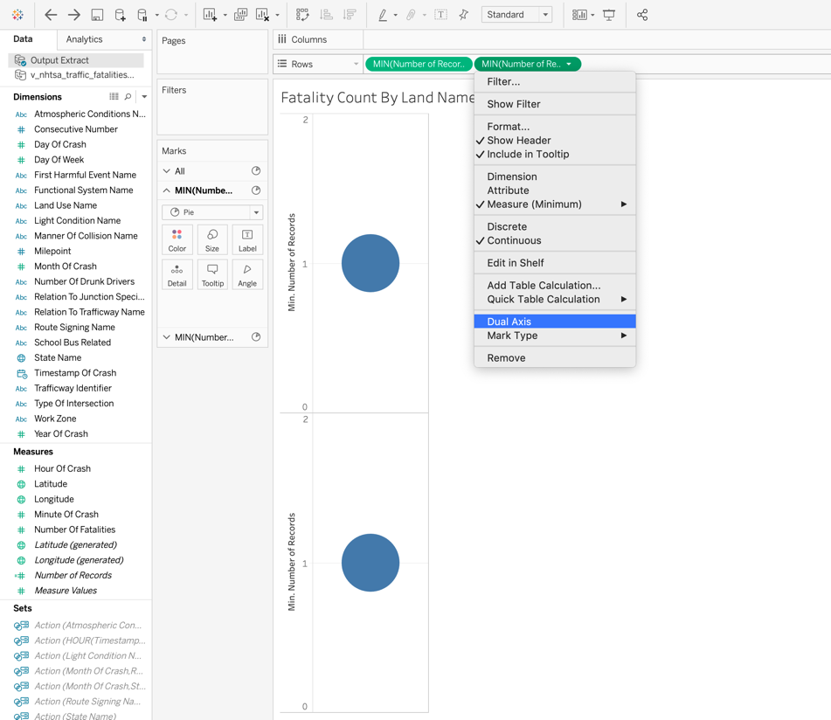

* Under marks, expand the section for first pie chart -> drag and drop the land use name on colors and text as shown below.

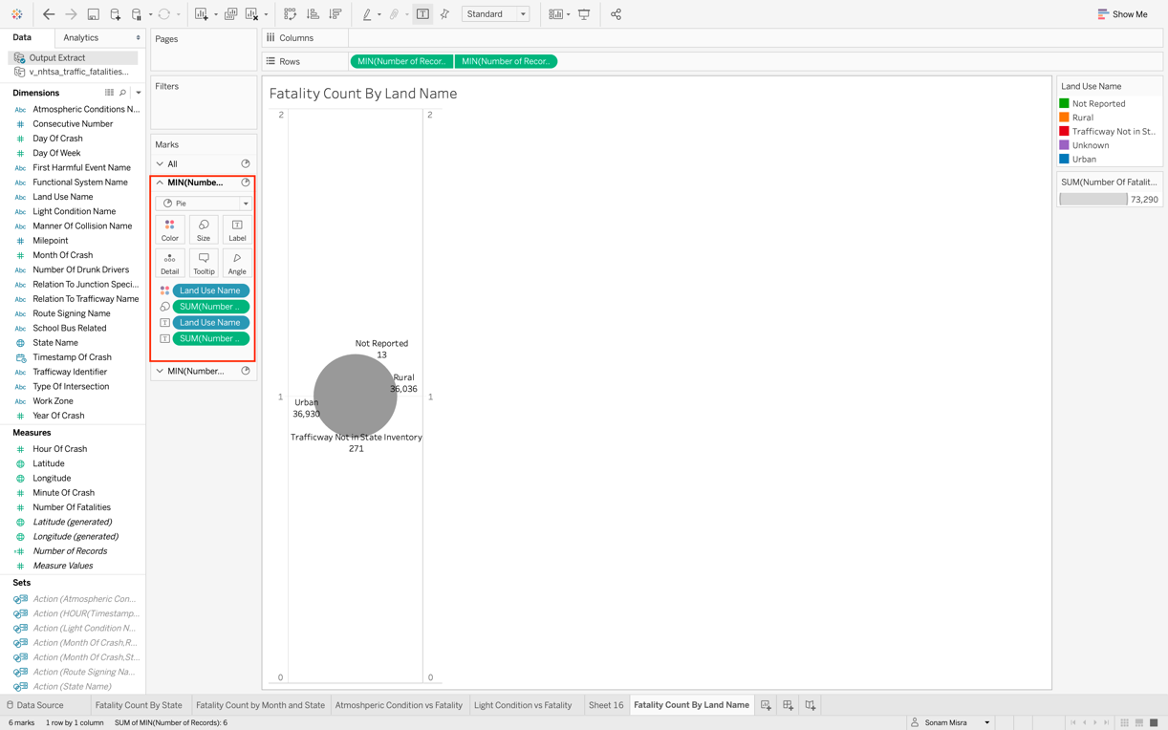

* Expand the section for second pie chart and adjust the size as below. Finally, you will be able to see the donut shape chart.

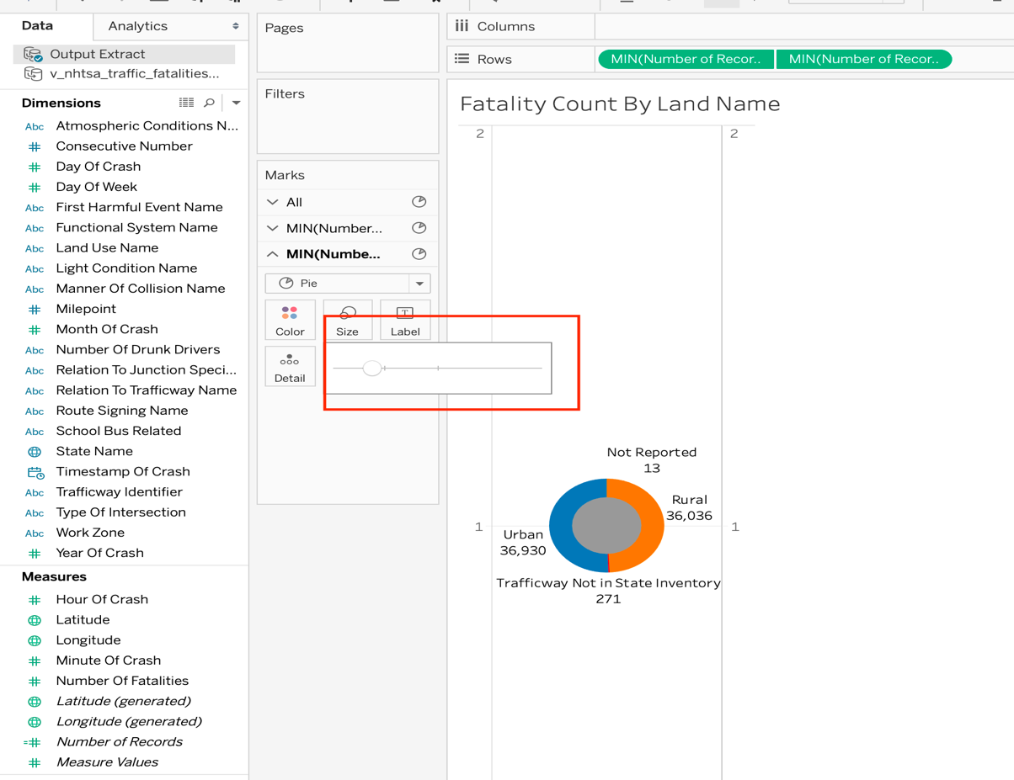

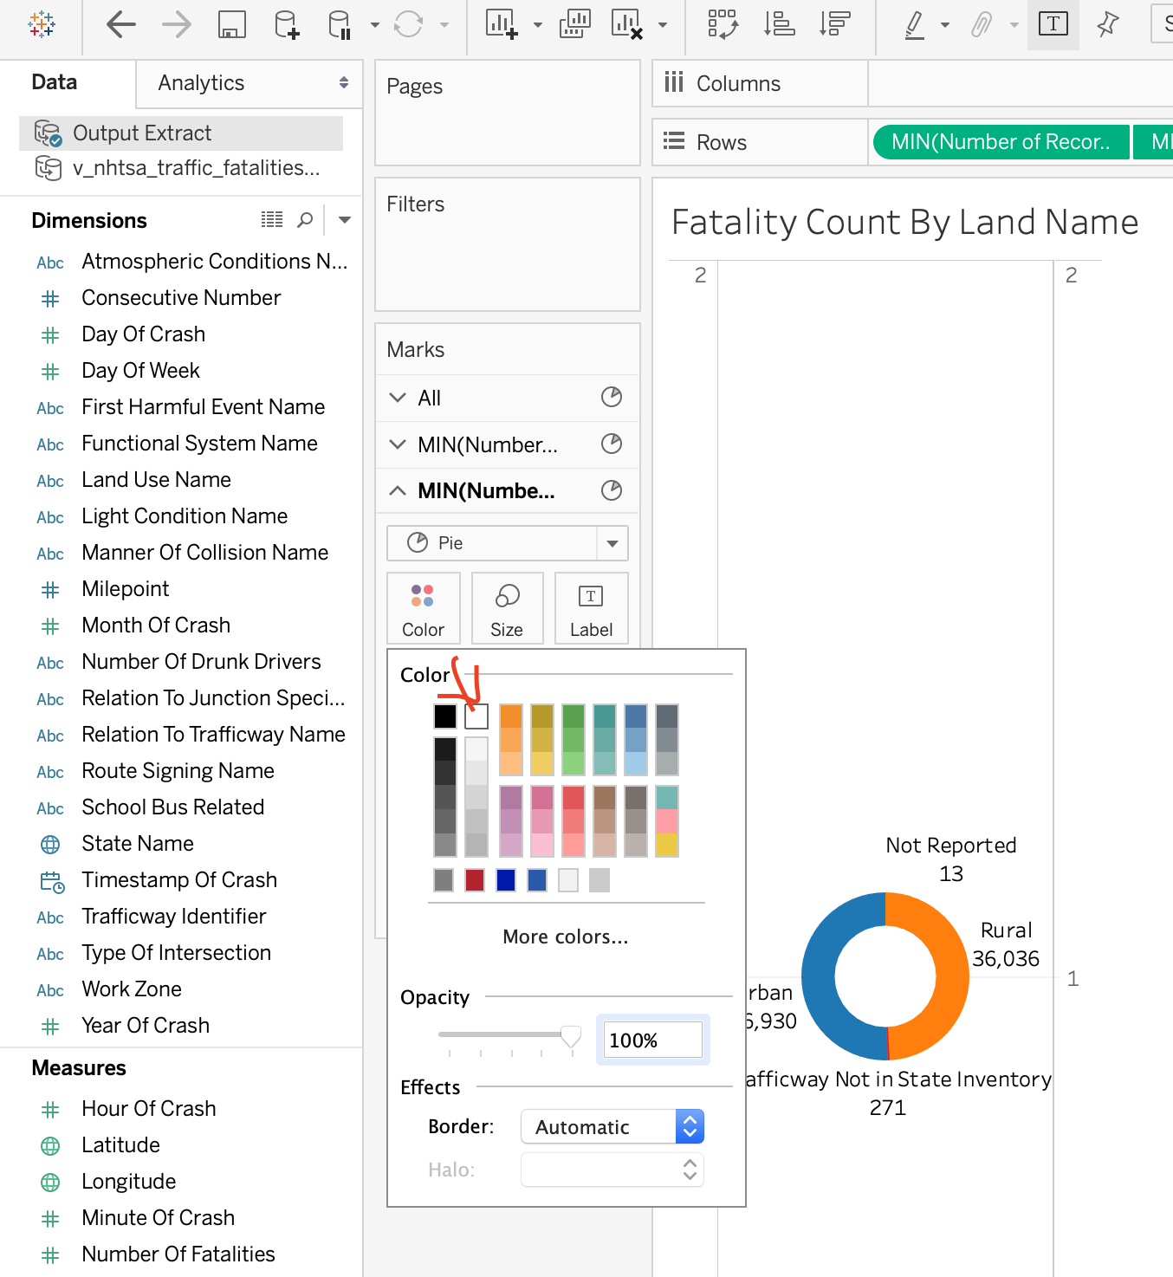

* Final output should look like below. Here we observed that overall on the national level the fatality count for urban is slightly more than the rural areas.

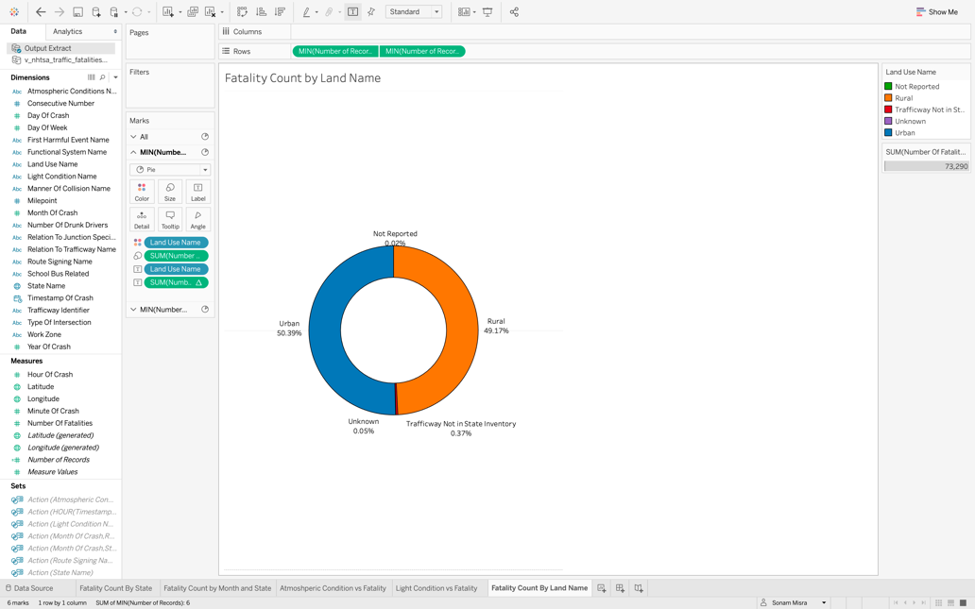

However, this count changes state by state. Add state name to the filter section and then select California. You will see the below changes.

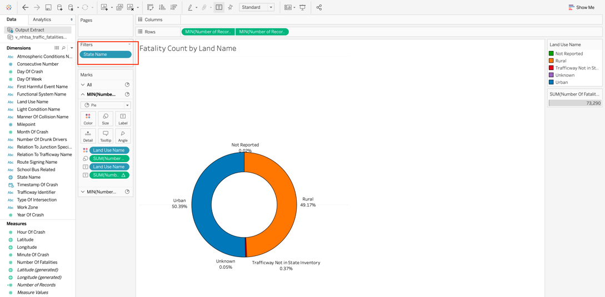

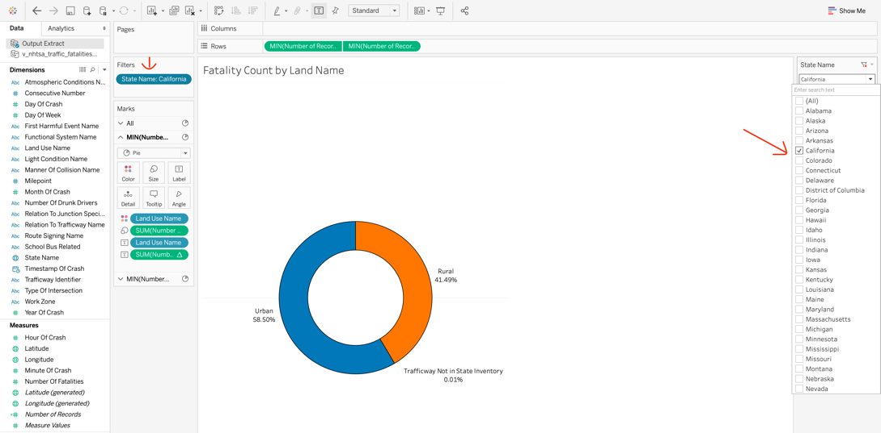

**Worksheet** 6: **Total Fatality Count**

**Purpose:**

For a quick glance at the statistics we will display these on the dashboard. To make this follow below steps.

**Steps**:

* Drag and drop the consecutive number to rows section. Consecutive number is the unique id of each accident.

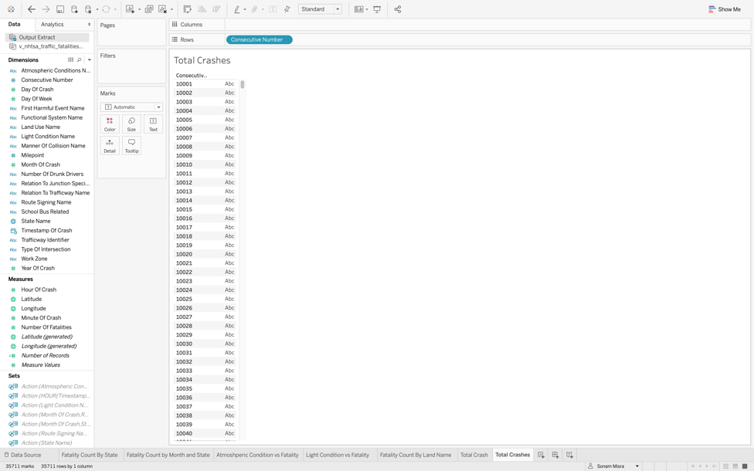

* Change the measure to count since we want the total number of accidents.

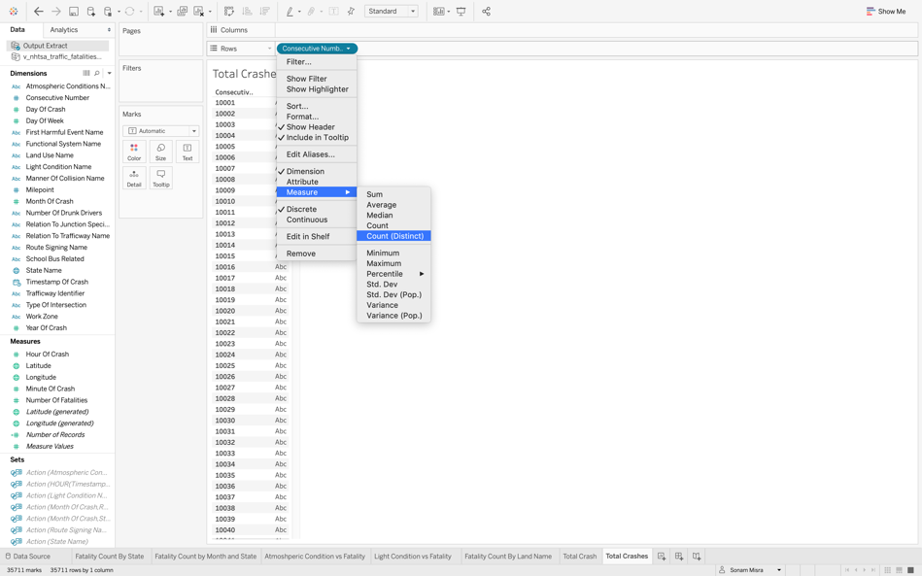

* Change the visualization and the first filter in the show me in upper right side.

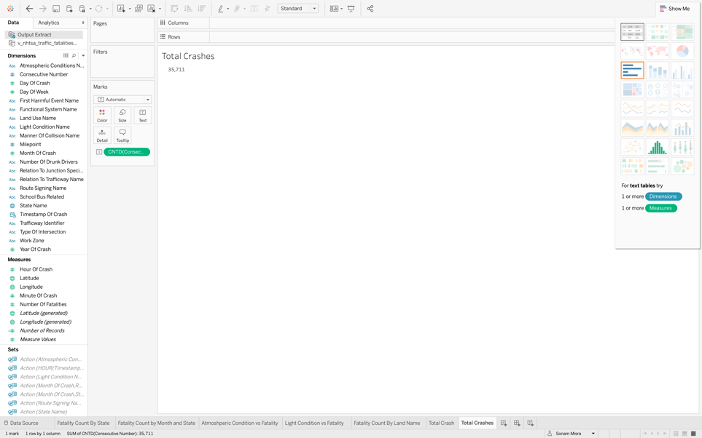

* To change the color, click on formatting as show below and adjust the color and size.

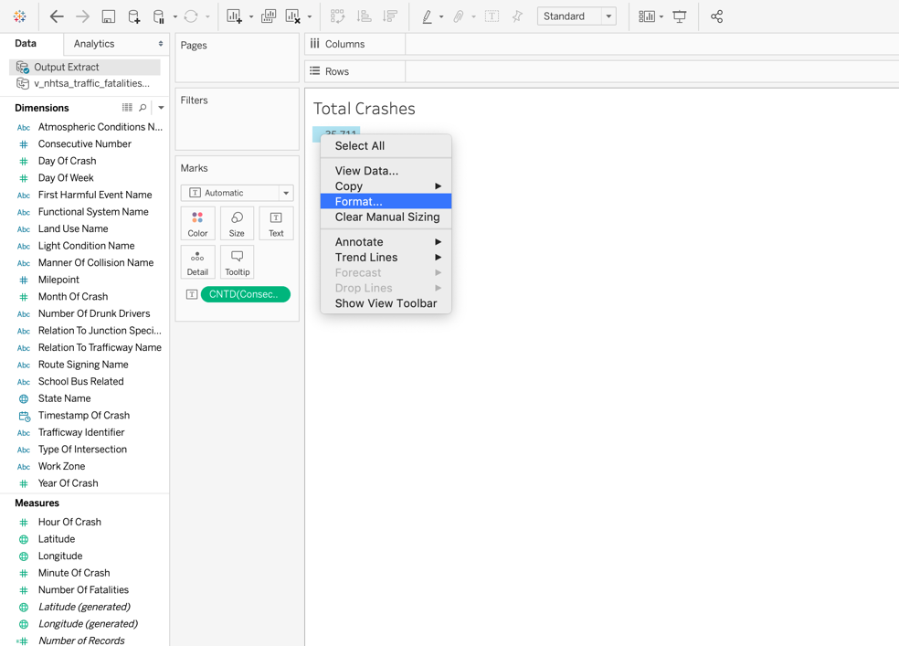

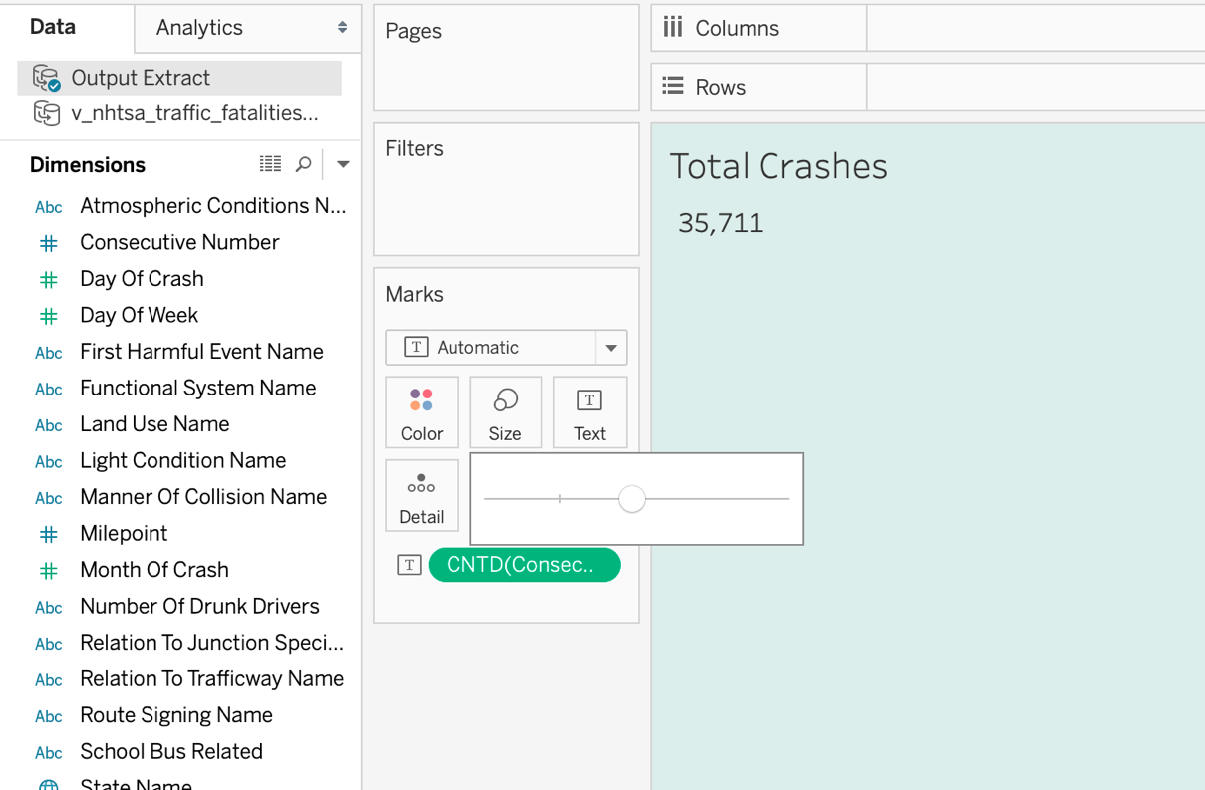

* Repeat the same steps for total fatality count and get the below output.

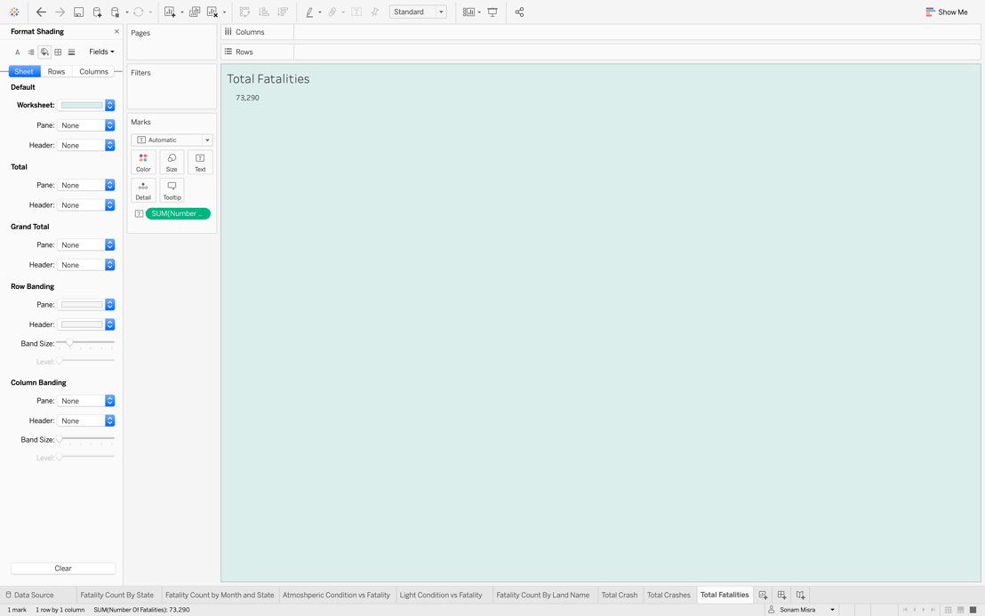

**Create Dashboard**

**Purpose**:

Now we will assemble all the worksheets which we created into a single view and that is called a dashboard. This dashboard will be presented to the audience. Perform below steps to make an interactive dashboard.

**Steps**:

* + - * + Create a dashboard by clicking on the new dashboard icon at bottom right corner of the workbook.
        + You will find a blank dashboard with the already created worksheet on the left side.

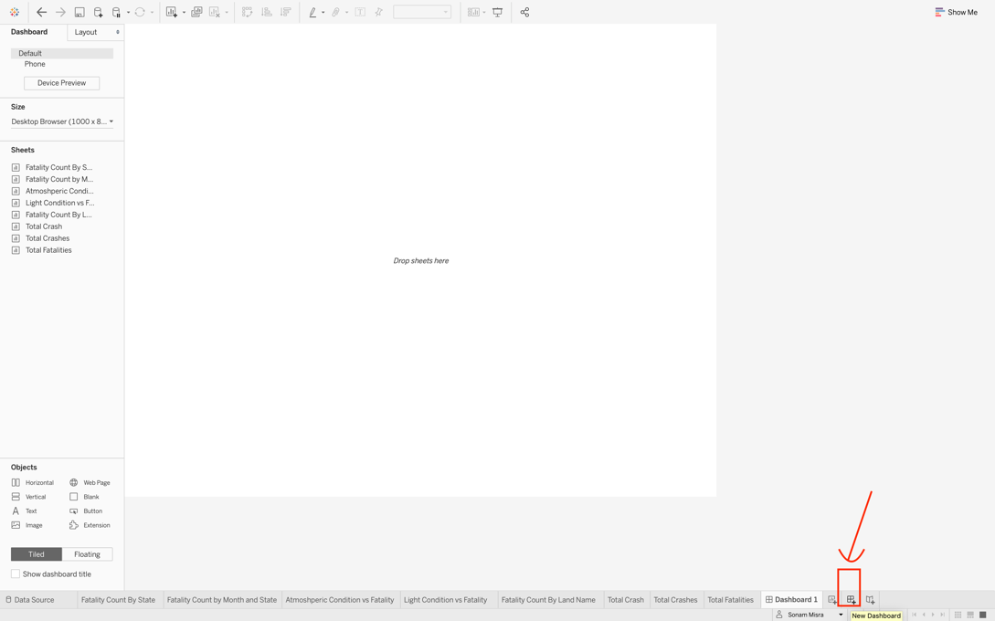

* + - * + In the object section given at the bottom left side, select the floating option. It will allow the objects to overlap whenever required.

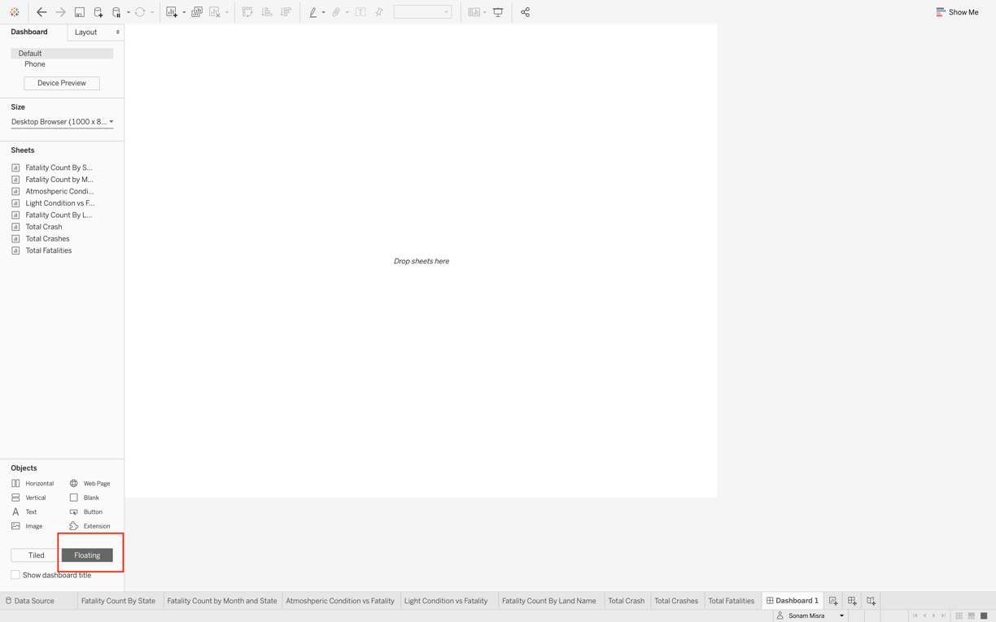

* + - * + Drag and Drop the worksheets one by one and show filter (state name) for Fatality Count by State.

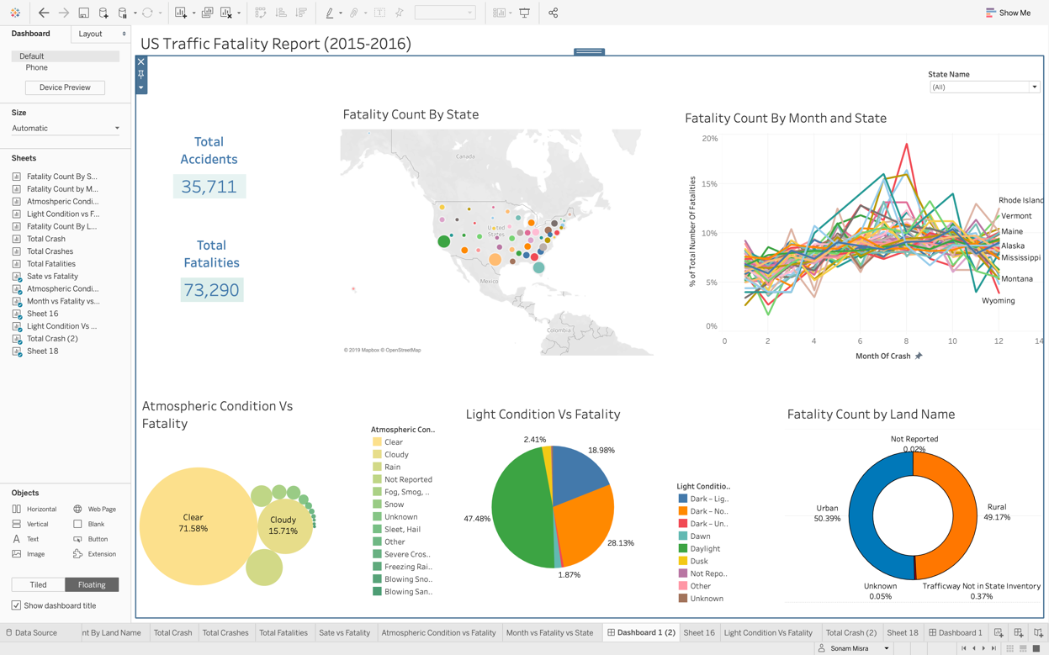

* + - * + Connect this filter to all the worksheets present on the dashboard. So that when you choose a state, all the worksheets display changes accordingly. Also, connect all worksheets by selecting use as filter option present on the right corner of each worksheet as shown in the picture below.

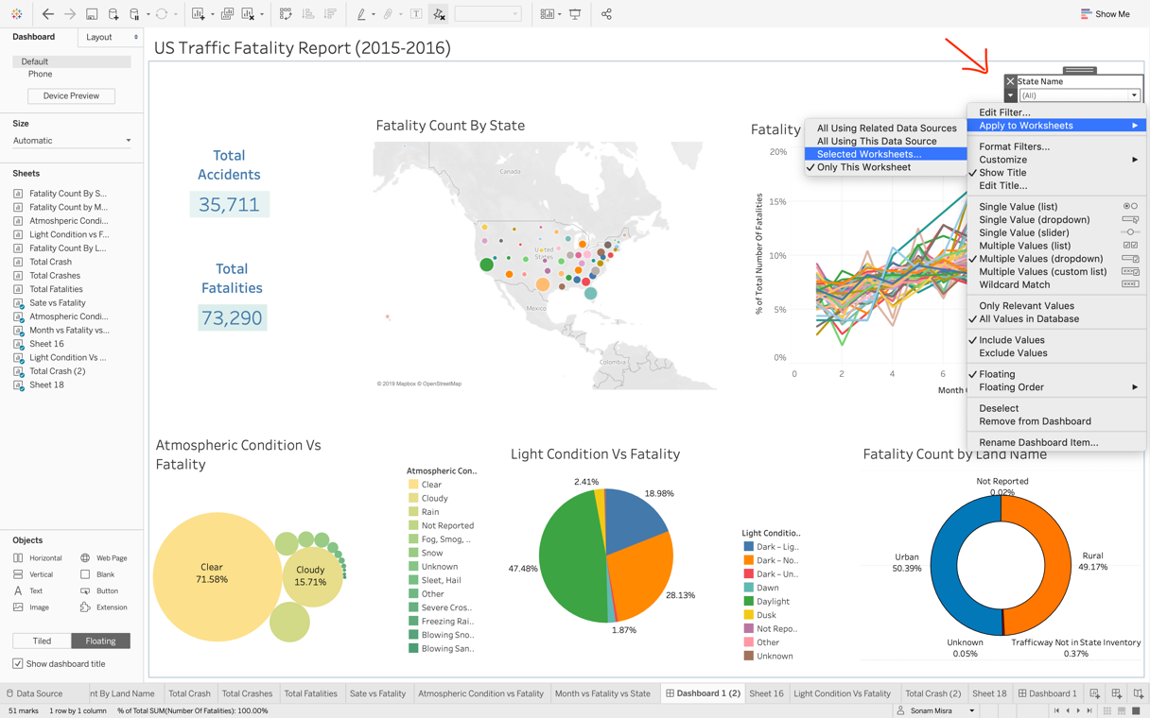

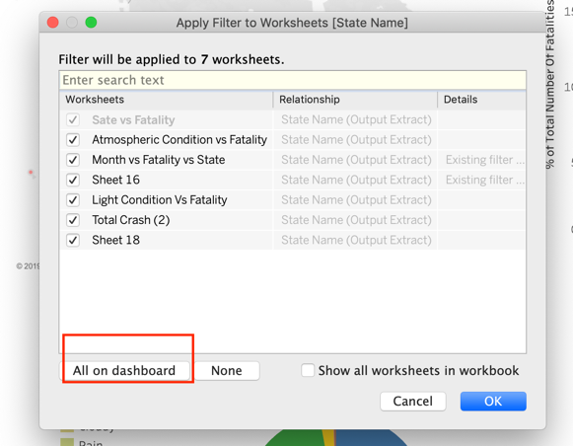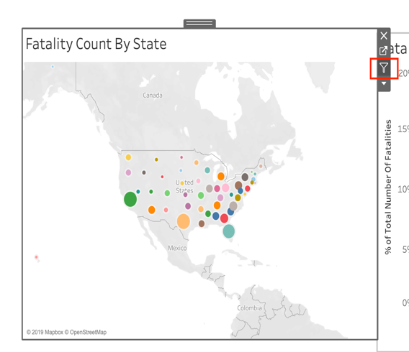

* + - * + Final dashboard would look like below.

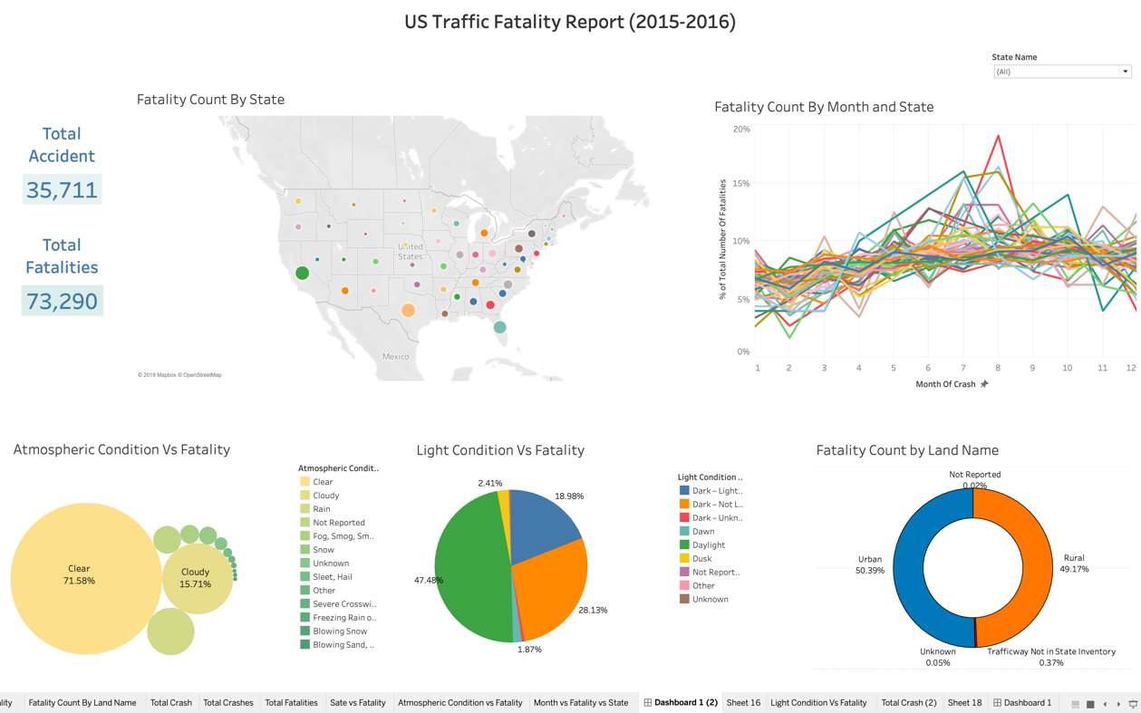

**Publish Dashboard**

Tableau dashboard can be published to Tableau Public. Once its published to Tableau Public it can be easily accessed from remote locations and can be shared with reporting authorities. To publish it follow the below steps:

* First you need to sign into Tableau Server with your credential.

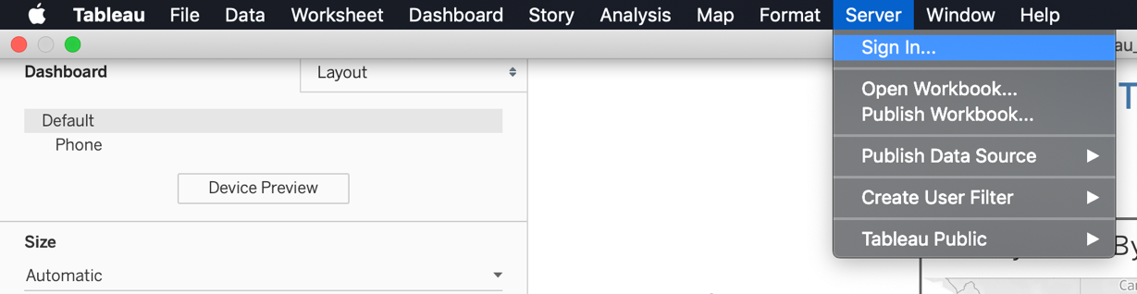

* Then save this workbook to tableau public.

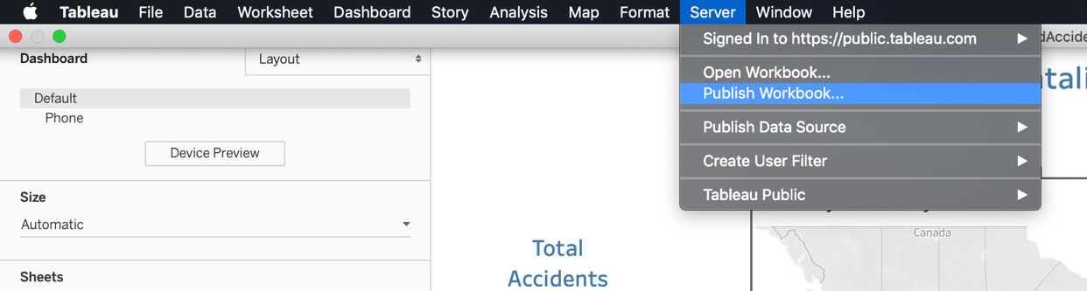

* Here is the published dashboard link:

<https://public.tableau.com/views/Tutorial_Dashboard_RoadFatality/TutorialDashboard1?:display_count=y&publish=yes&:origin=viz_share_link>

1. DELIVERABLE 2 - STORYBOARD:

An interactive and well explained Storyboard is created by the business Intelligence team to help the U.S department of transportation to analyze the road safety issue in the state of California. The aim of this storyboard is to present the investigation on an issue and statistics in a way that can help the department to understand key problems and work on their strategies to improve the road safety. The storyboard created for this purpose has the below KPIs.

* Which state had the highest number of accidents and fatalities?
* Total number of Accidents in that state?
* Total number of fatalities in the identified state?
* Which location (mile point/latitude/longitude) saw the maximum incidents in that state?

Below is the link of the published storyboard:

<https://public.tableau.com/shared/JPWZZRKR8?:display_count=y&:origin=viz_share_link>

* 1. Scenario:

The U.S department of Transportation wants to find out the state among all the states in U.S. which is high prone to accidents. They want to make a special team for that state to do the research and find out the reasons of high fatality rate in the identified state. The department wants the team to analyze the issue of identified state and reduce road fatality incidents in the identified state. If the research team is successful in their project, similar projects will be carried out in other states. The ultimate goal will be to identify the peak hours, states, highways and locations which are most dangerous. It will enable the government to take better security measures on these locations. The Highway patrol teams can be trained accordingly to provide highest level of service and security.

You are identified as a key person of the research team to investigate the factors influencing traffic fatalities in the identified state and need to perform progressive investigation to come up with the final conclusion. You need to analyze the data and evaluate the trend and relationship between the factors and road deaths. You are in the year 2017 and need to evaluate the data for past two years. You want to demonstrate your discoveries by a visual representation which will clearly explain the various factors that causes high road fatalities.

* 1. Purposes/Questions/Application:

**Purpose**:

Rate of accidents vary from state to state. Some states have higher traffic fatality rate as compared to others. Reasons could be many! It can be a poor weather condition, driving under the influence of alcohol or poor road conditions. The U.S department of Transportation wants to focus on the state with worst situation. They want to identify the reasons about such high fatality rate. The findings can help the department to restructure their policies and service to improve security measures.

To provide these safety measures, in-depth understanding of the past accidents is required. The research team needs to understand what caused these accidents in past. Evaluation of each accident case is needed. The research department needs to conduct research to study unsafe behaviors of drivers, environmental factors and locations which are at higher risk of fatal crashes. For that purpose, descriptive and diagnostic analytics needs to be performed.

**Questions**:

They need the answer the following question so that a clear picture of the problem can be formed, and real issues can be highlighted.

* Which state had the highest number of accidents and fatalities?
* Which mile point saw the maximum incidents in that state?
* What were the main factors that influenced the road accidents?
* What locations in that state were most dangerous?
* How atmospheric condition can impact the risk of fatal crashes?
* What is the most common type of crashes?
* Which month of the year had maximum incidents?
* What time of the day had maximum incidents?
* What is the impact of drunk driving?

**Application**:

The outcome of these research questions can be very helpful to focus on the real issues. If the security team identify the particular time when there are high chances of dangerous incidents, they can be better prepared. Also, the drivers can be guided about the risk associated on certain locations, days and peak hours.

On the basis of these findings department can reevaluate their current strategies and figure out their priorities. If the department can control the situation in the identified state. They can make the similar strategies for other states as well. They will make the decisions to change their policies. The department will make the following decisions-

* Does that state need special department to control the situation?
* Do they need to implement new road signs?
* Do they need to change the fine system in that state?
* Do they need to change drunk driving rules for their state?
* Do they need to update their public safety manuals?
* Do some locations need more security force than others?
* Do they need to take care of road conditions or road structure to avoid accidents?
* Do some weekdays need more service force than other days?
  1. Procedure – Storyboard

To investigate the factors which caused the highest accidents for the identified we will build up a storyboard. The storyboard will explain in detail the entire scenario step by step so that we can reach to the conclusion for our research question. The storyboard can include worksheets or dashboards. You need to perform the below steps-

**Purpose**:

Create different views (worksheets/dashboards): You need to start by building views and dashboards which will be integrated in a story later on. You can use the worksheets which you have already created for dashboard if required.

**Steps**:

In the first story point you may reuse the worksheet which was created earlier. This worksheet highlights the three states which has the highest fatality count for the year 2015-2016. California, Florida and Texas were the top states with California having highest fatality count. We will explore further in the story why California has so many incidents as compared to other states.

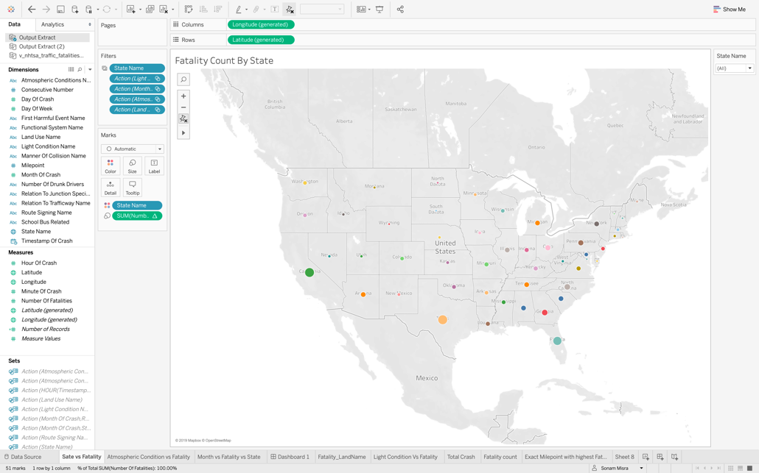

**Purpose**: Next create a new worksheet and rename it to mile points with highest fatality.

**Steps**:

* Drag the fields latitude and longitude from the measures and place it to the rows and columns as shown in the picture below

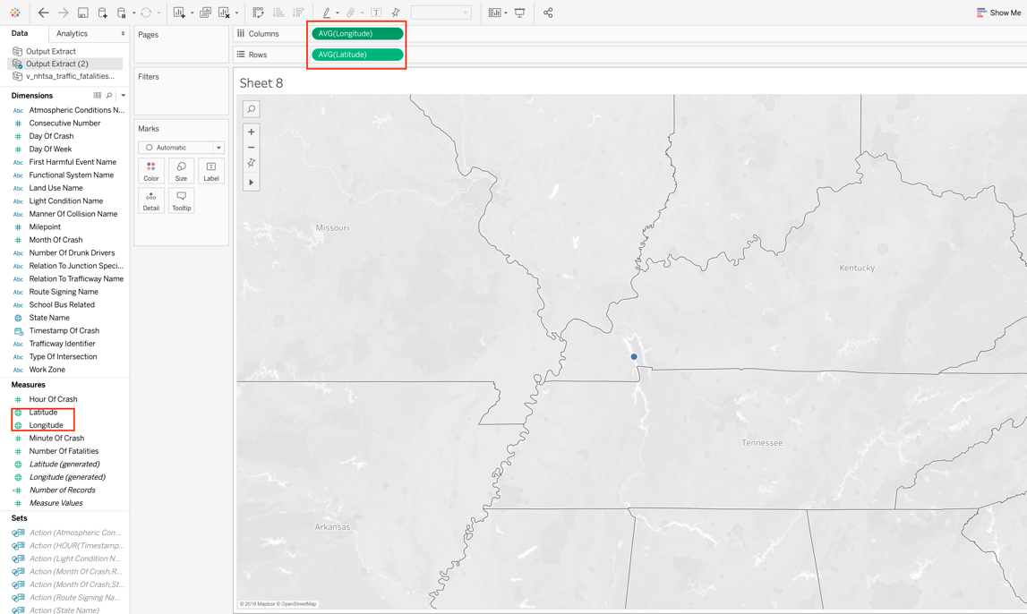

* Change the longitude and latitude to dimensions as show below.

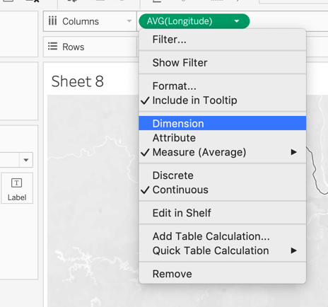

* We are focusing on California state. So, we need to filter out the mile points for California state as shown below.

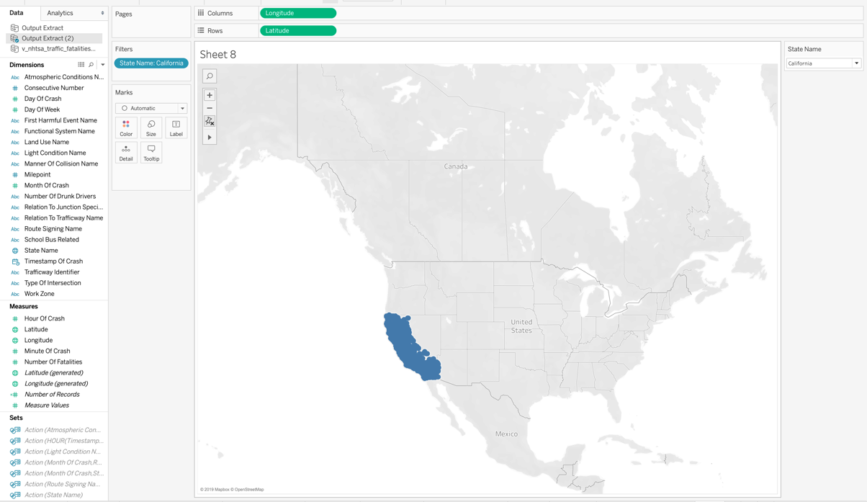

**Purpose**:

Next we will add mile point to the color section under marks, which will represent each mile point of incident with a different color.

**Steps**:

* To view which mile point has highest incidents we will drag number of fatalities from dimension and drop it to the size section as show below.

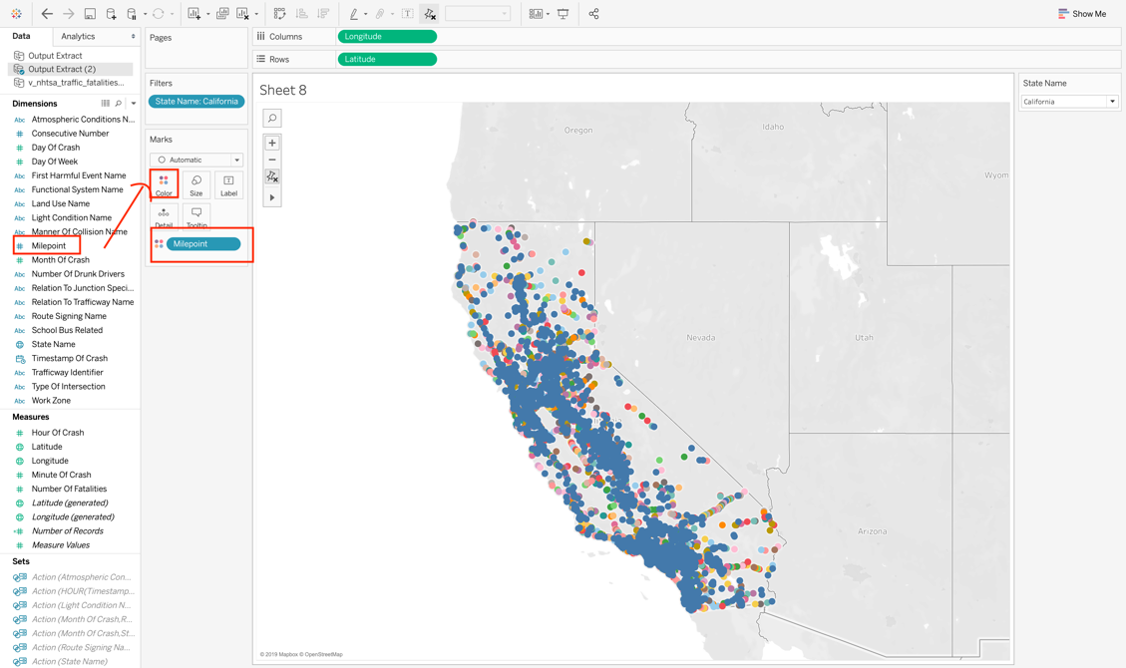

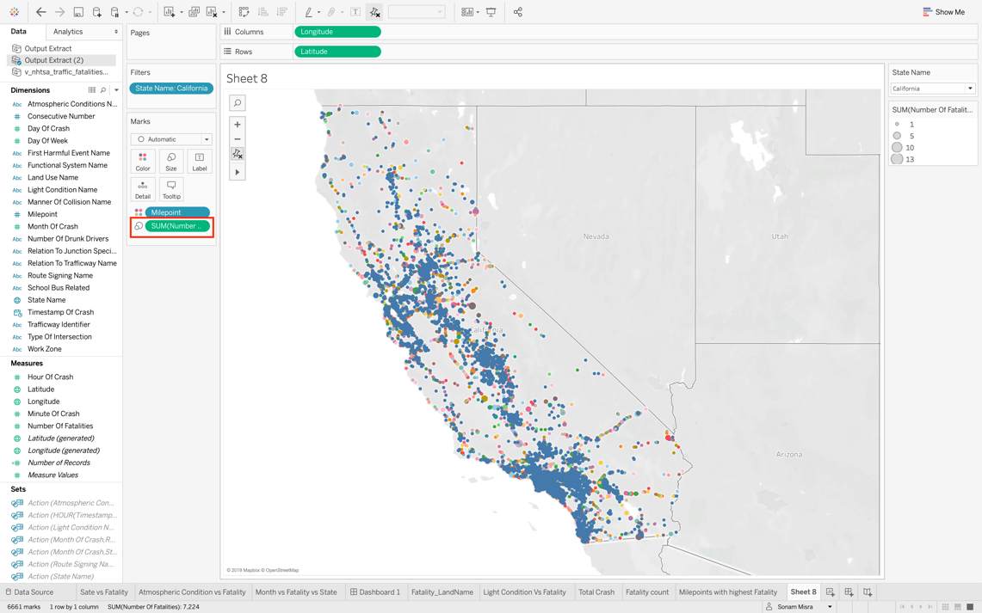

* To visualize exactly which mile point saw maximum incident, we will select the maximum size of the number of fatalities i.e. 13 which you can see on the right side of the screen above.

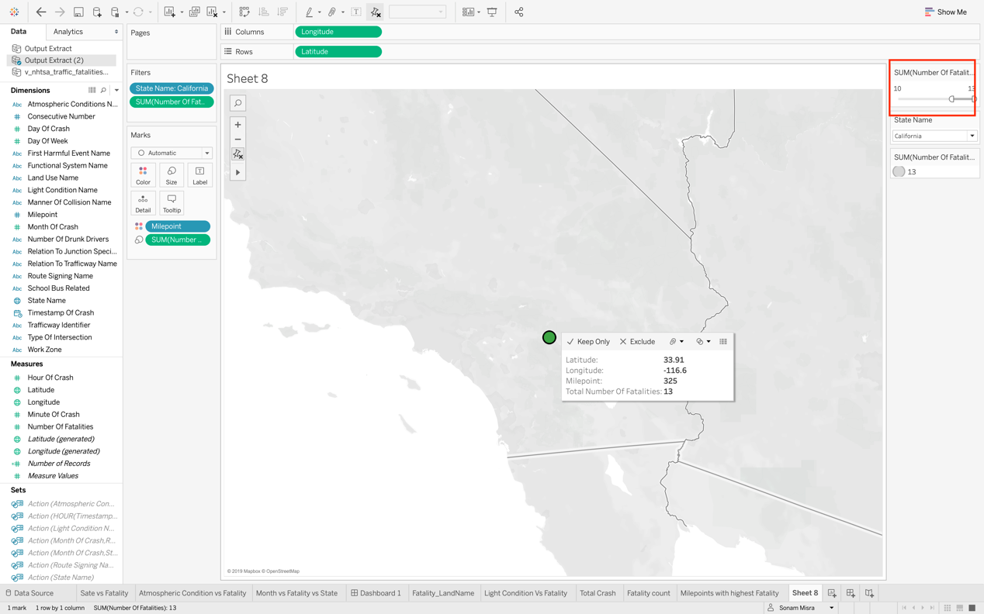

**Purpose**: Next we will create a dashboard which will present high prone accident areas in California. We will explore which highways and roads are riskier. And which land area saw the maximum incidents, rural or urban. Following steps need to be performed.

**Steps**:

* First, we will create a new worksheet and rename it to Land name vs Traffic Fatality. Here we will compare which land type has the highest fatality count across the 12 months. We need to figure out the relationship between months and land type.

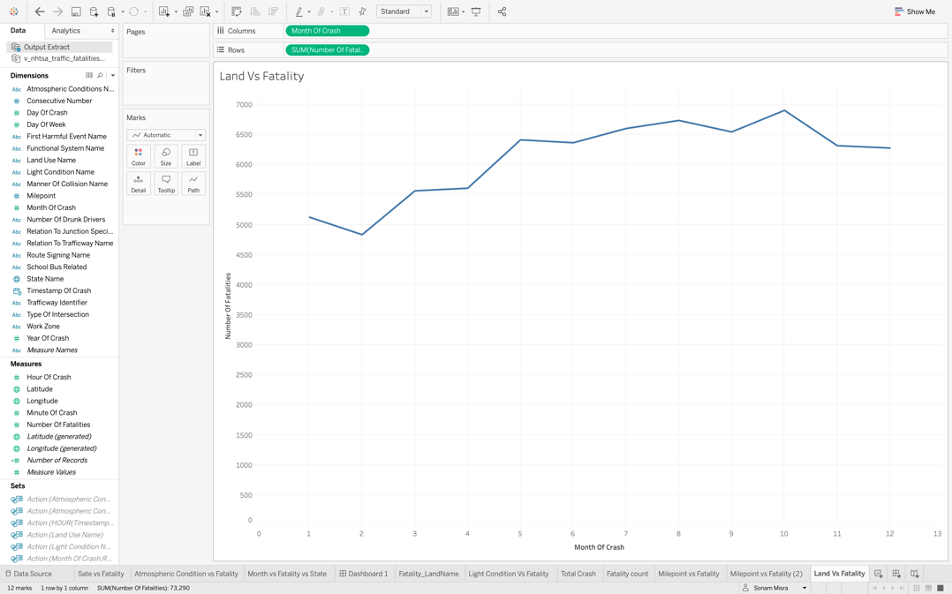

* Drag and drop land use name on the color under marks as show below.

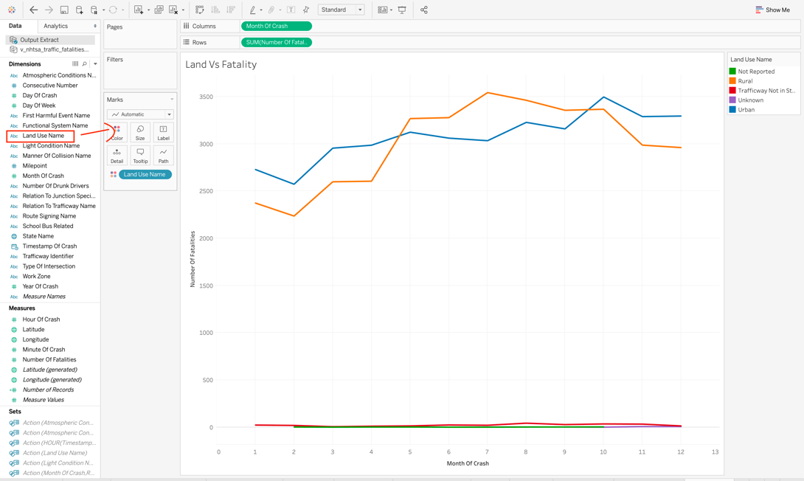

* Drag and drop the land use name and state name in the filter section and select California as a state as shown below.

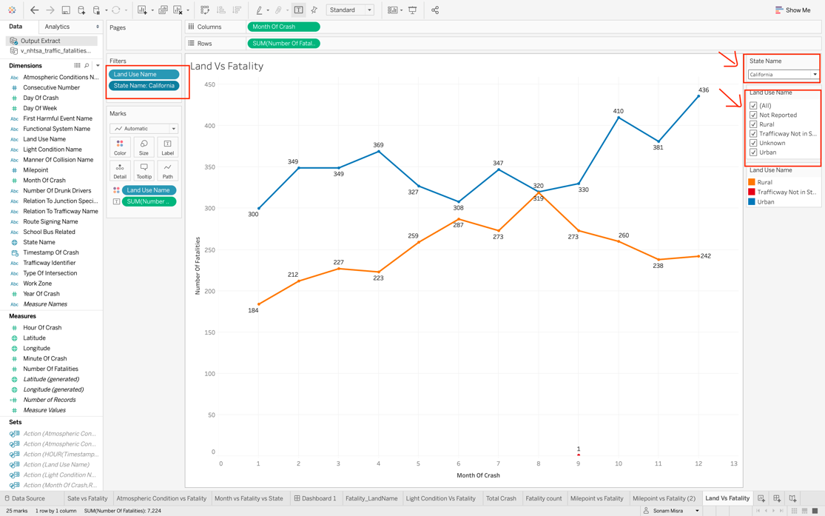

* Here we can see one interesting fact that the month of august shows the maximum number of road fatalities for rural area as compared to urban area.

And December is a very critical month for urban area as highest accidents are seen in that month. It may be because of the rush of holiday season.

**Purpose**:

Next you will create a new worksheet, to analyze the number of fatalities witnessed on different routes in U.S. You will need to choose an area chart for this purpose. It will allow you to compare the fatalities over the period of 12 months. Follow the below steps:

**Steps**:

* Drag and drop the Month of Crash and number of fatalities to the rows and columns respectively as show below:

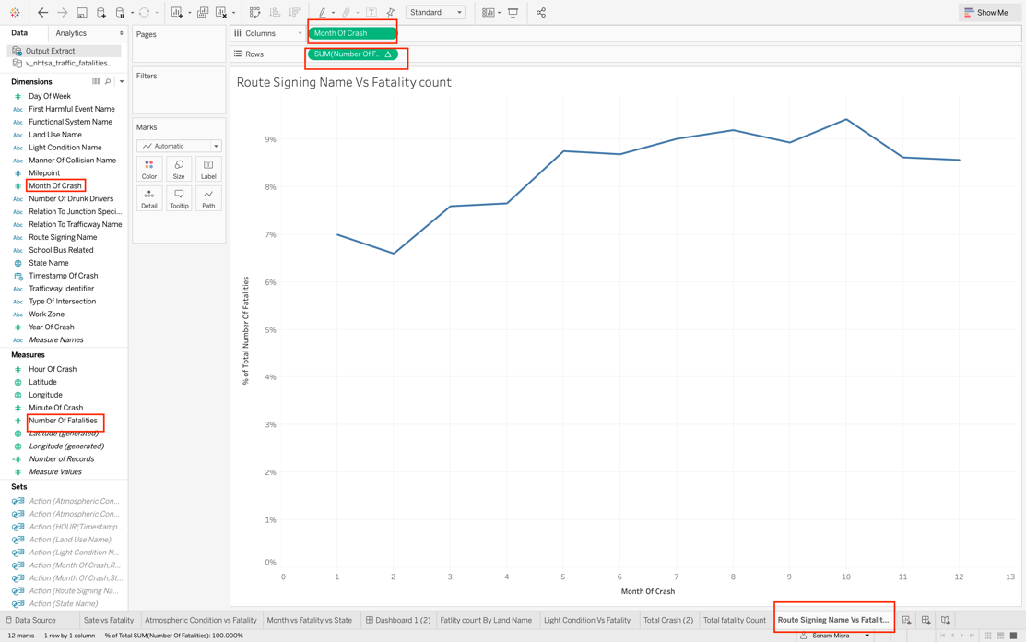

* Click on show me and choose the area chart as shown below:

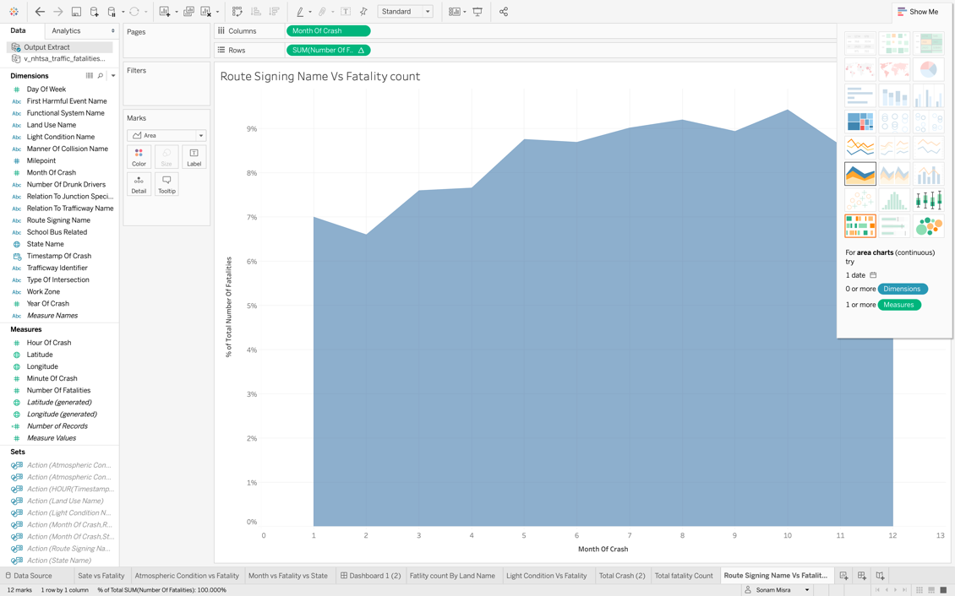

* Drag and drop the state and route signing name from the dimensions to the filter section as show below. Also, drop the routes signing name to text and color under label so that different routes can be identified individually. In the state filter select California as the state since we are analyzing this state:

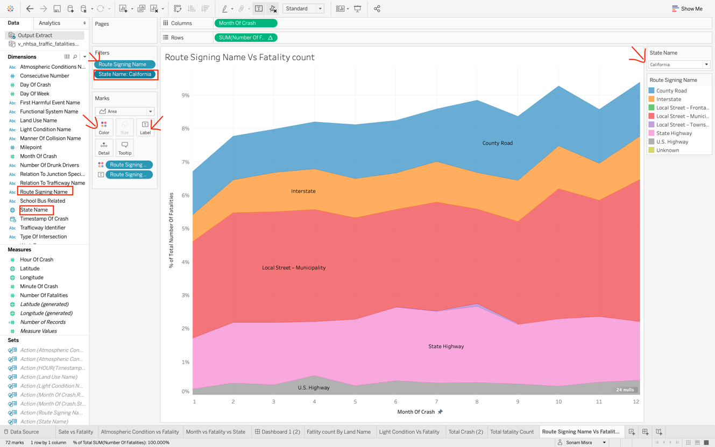

* Next merge the above two worksheet into a dashboard. Create a new dashboard from the icon present on bottom right and drag and drop these two worksheets.

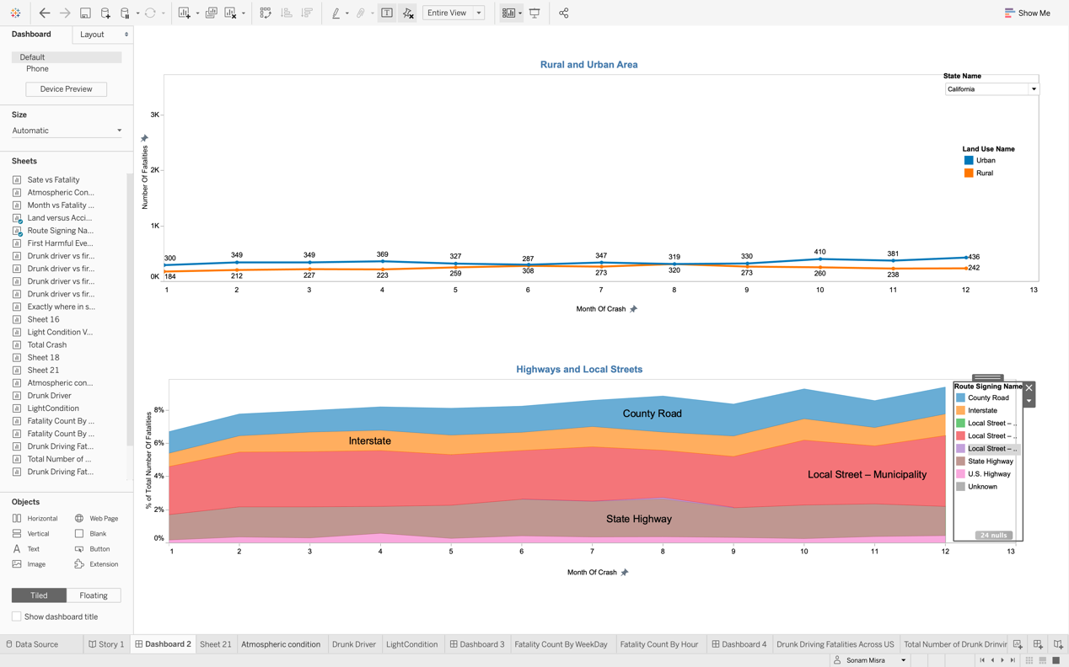

**Purpose**:

Create a new worksheet and rename it to fatality count by hour. Here you will analyze the fatality count in state of California on the basis of each hour. It will help to understand which hour of the day is most dangerous in terms of road fatalities and security team need special attention. Follow the below steps :

**Steps**:

* Drag and drop the timestamp and number of fatalities to the rows and column section as show below. Change the timestamp to Hour.

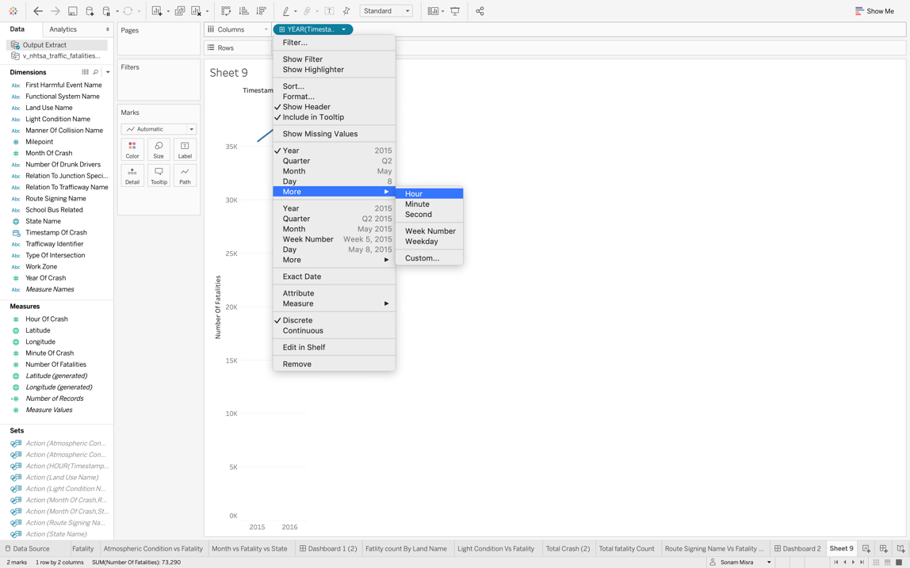

* Now drag and drop the state name to the filter section and select California. You can also change the color of the visualization as show below.You will find the peak hours when maximum fatalities happened. It is mostly during the midnight and evening time.

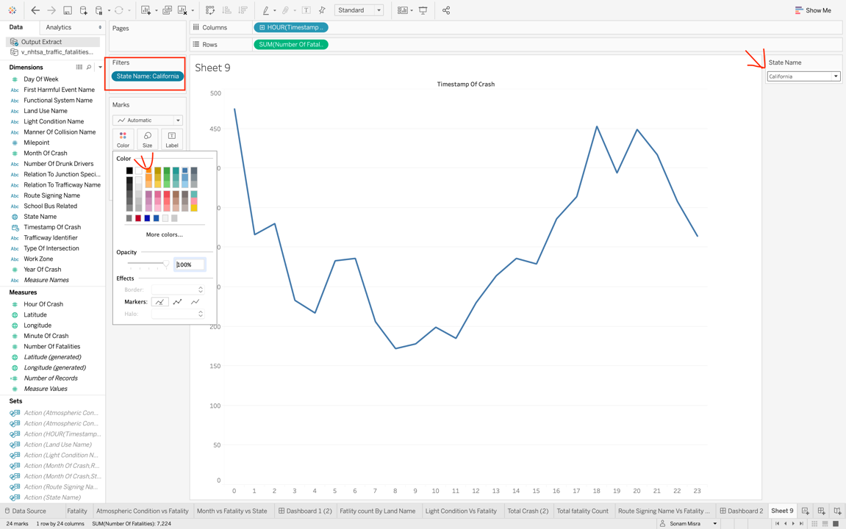

* Next create a new worksheet, to analyze the fatality count over the weak days in state of California. You will be to able to figure out which weekday reported most of the fatalities in year 2015-2016. And on which day the security team need to pay more attention. Follow below steps:
  + Drag and Drop Time Stamp and number of fatalities to the rows and columns as show below. Change timestamp to Weekdays and Drag the State Name to the filter section. Next filter out the results for California.

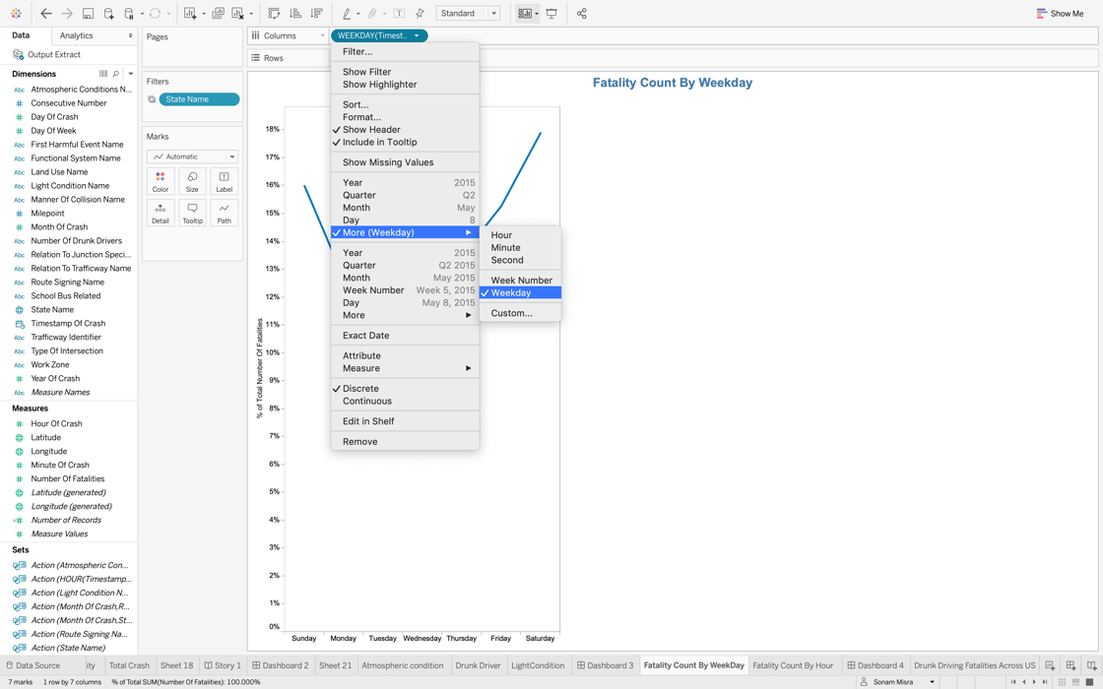

* Final output will look like below:

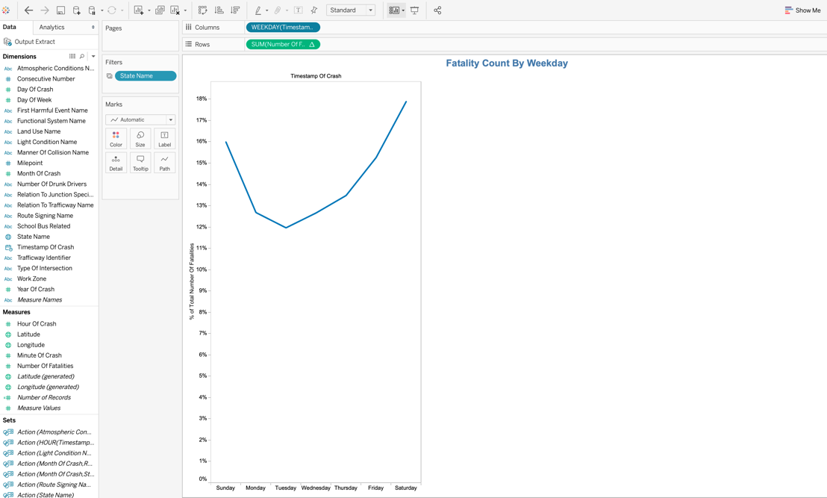

* Merge the above two worksheets into one dashboard as show below. For that create a new dashboard and drag and drop the worksheet to dashboard.

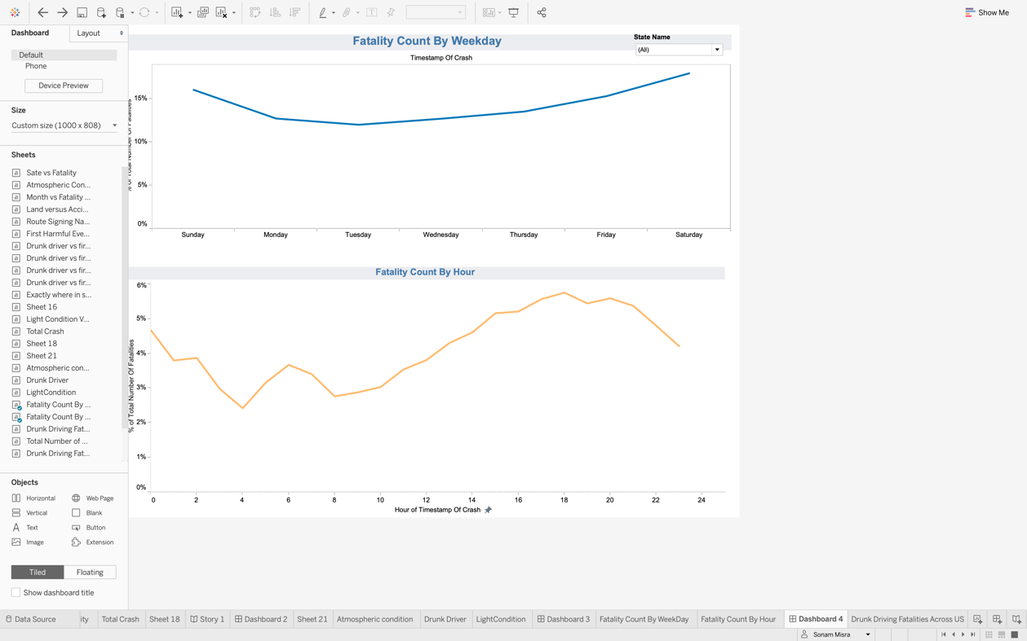

**Purpose**:

Next, create one more dashboard which will have three worksheets. The purpose of this dashboard is to explore the reasons which cause fatalities like impact of drunk driving, light conditions and atmospheric conditions in California. Follow the below to steps to create three worksheets.

**Steps**:

* First create worksheet to explore the impact of drunk driving. Create a new worksheet -> Drag and Drop Number of Drunk Driver and number of fatalities to the row and columns section. Drag and Drop the number of drunk driver and state name to the filter section and set the filter as show below. While selecting the number of drunk drivers opt out o as we want the data only for drunk drivers.

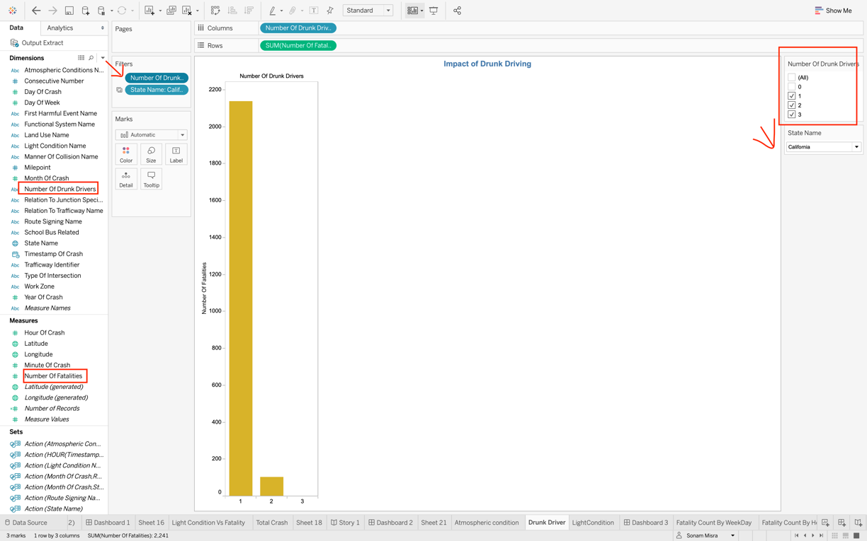

**Purpose**:

Next explore the impact of light condition. You will be able to explore which light condition are most dangerous and results in more accidents. Follow the below step.

**Steps**:

* Drag and drop the light condition and number of fatalities to the rows and columns as shown below.

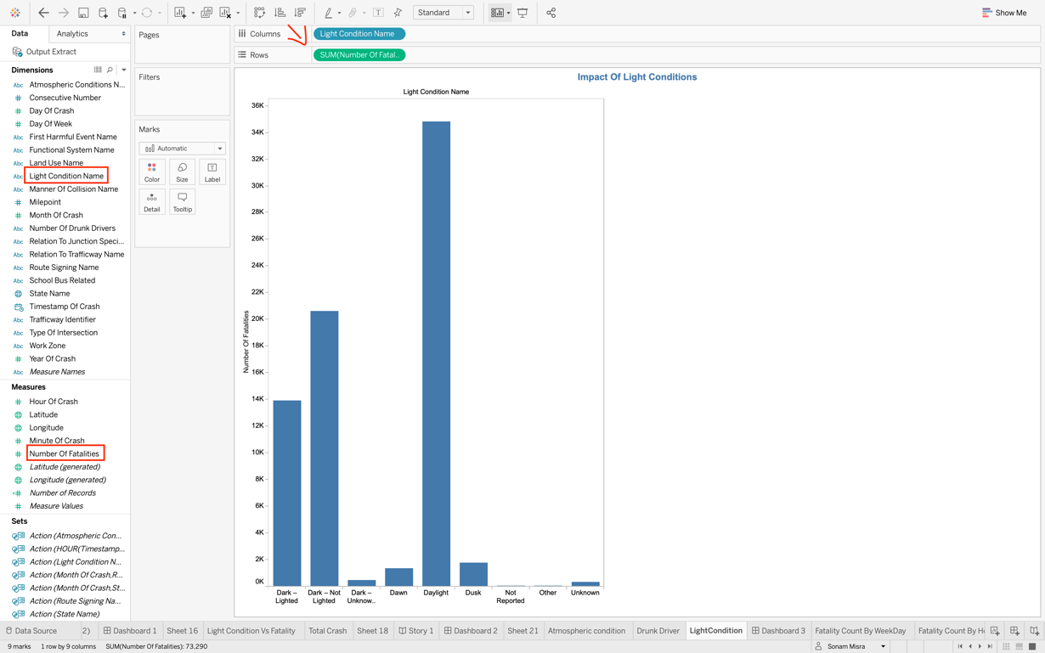

* Drag the state name to filter and select California and change the color of bars as per your choice.

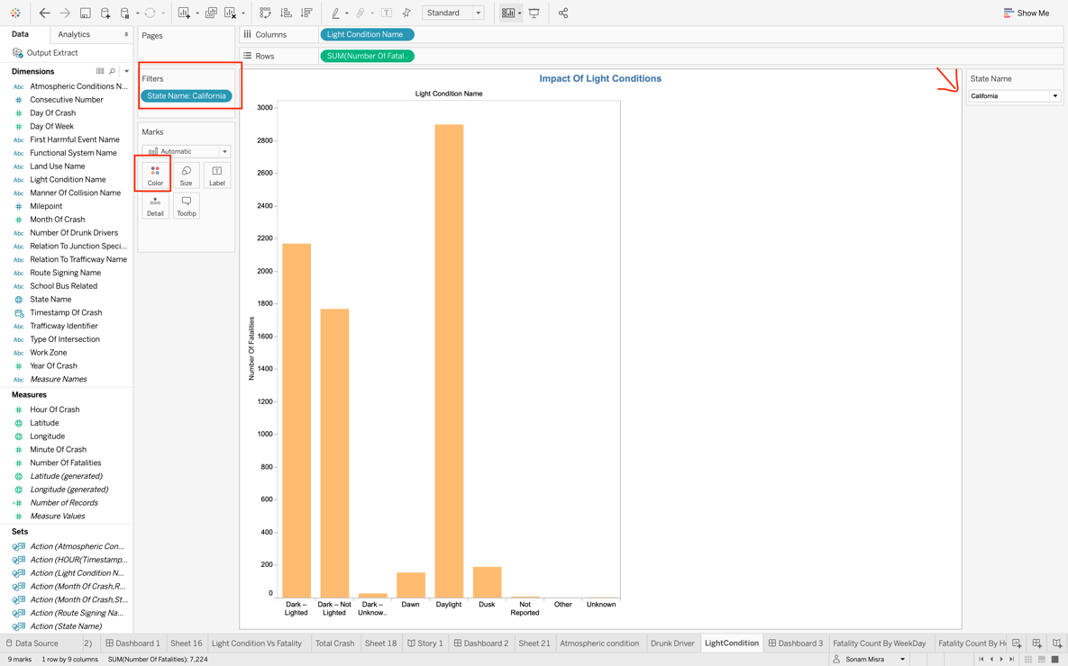

**Purpose**:

Next explore the impact of atmospheric condition on road fatalities in state of California. Here you will be able to figure out which weather condition can cause most of the incidents and when the security force as well as the drivers should pay more attention. Follow the below steps:

**Steps**:

* Drag and drop the Atmospheric condition and number of fatalities and add the state name to filter and select California as show below. Change the color of bars as of your choice.

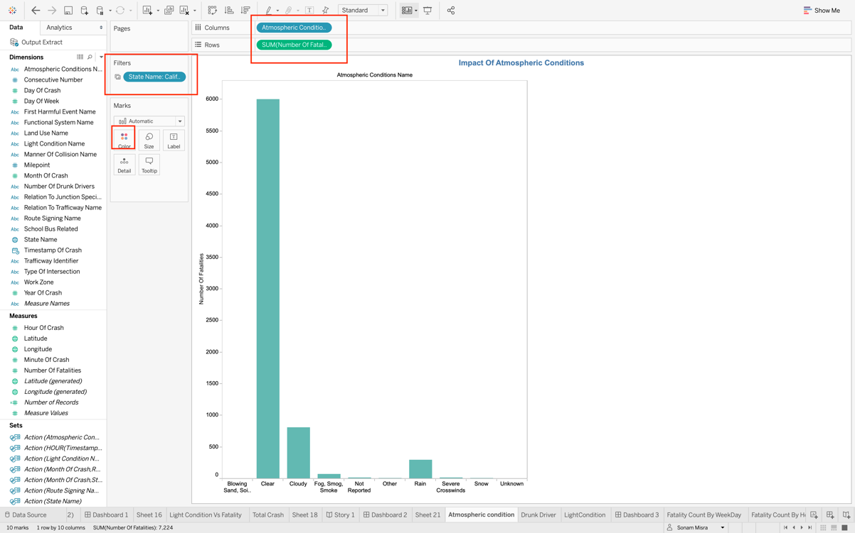

**Purpose**:

Merge the above three worksheets into a dashboard. So that all the three impact can be visualized at a glance in a storyboard.

**Steps**:

* Create a new dashboard -> Drag and drop the worksheets as shown below:

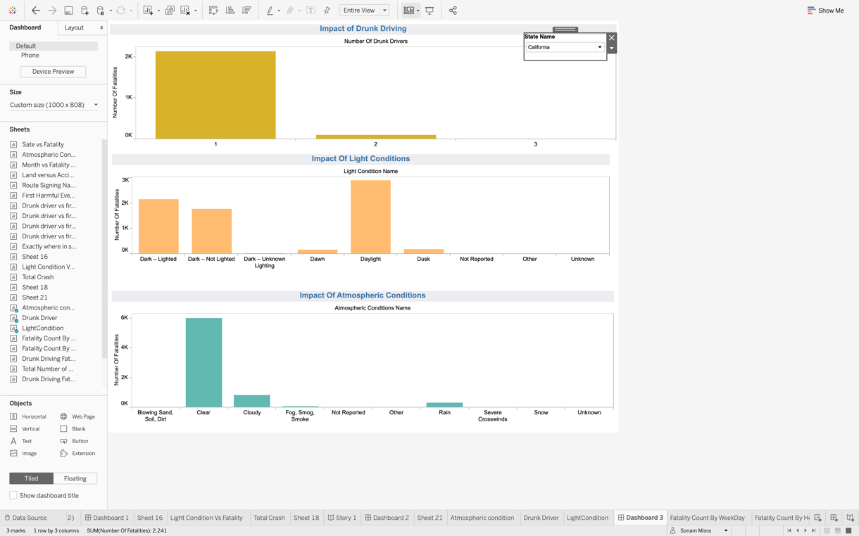

**Purpose:**

Next explore the accident events which caused maximum fatalities in California. There are multiple reasons of the road accident. It could be because of the poor roads may be a ditch or pedestrian came in the way etc. Explore this by following the below steps:

**Steps:**

* Create a new worksheet and drag and drop the first harmful event to the rows section as below:

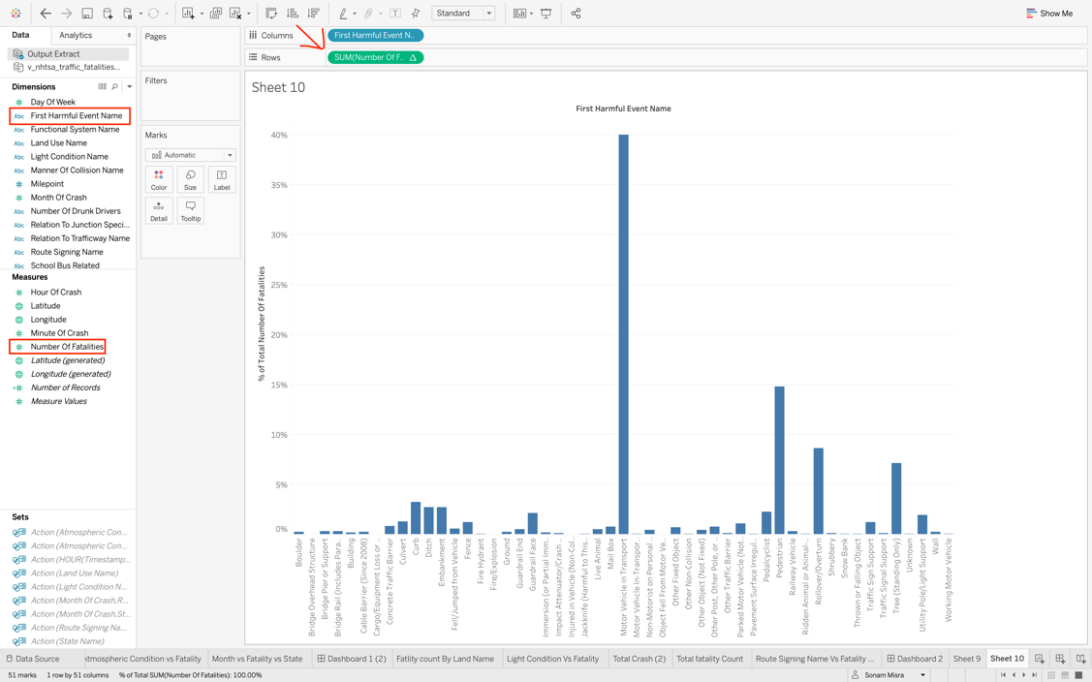

* Change the visualization bubble plot. Here bubble plot will help to easily detect which event was most harmful. Different colors and size of the bubble helps to visualize different types and measurement quickly at a glance. Drag and drop first harmful event to the colors under marks.

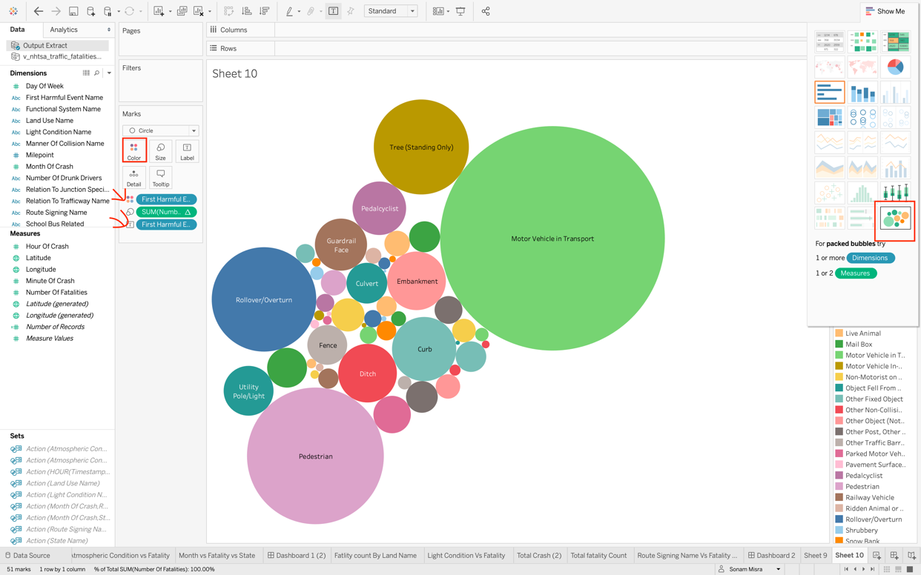

**Create Storyboard:**

Now you created all the worksheets and dashboards required for the storyboard to demonstrate the traffic fatalities in California state. In this storyboard you will present step by step visual explanations of your findings. Your storyboard will present the below points:

* **Steps**:
* Create a new storyboard by clicking on an icon at the bottom right-> Rename it to traffic fatalities in California.

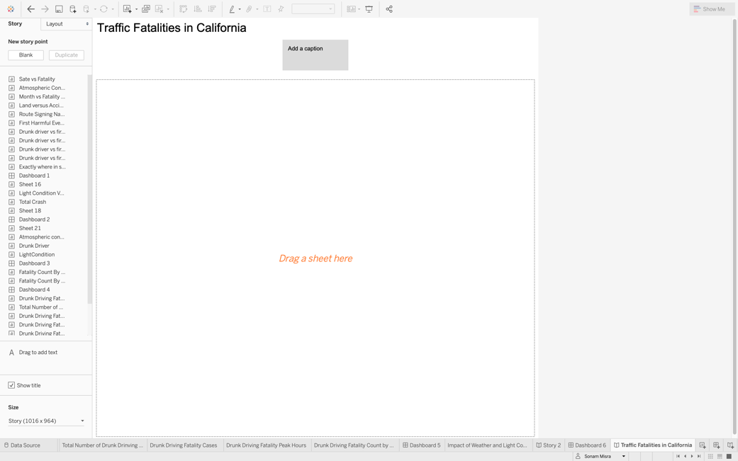

* Add a caption of your first story and drag and drop the first worksheet.

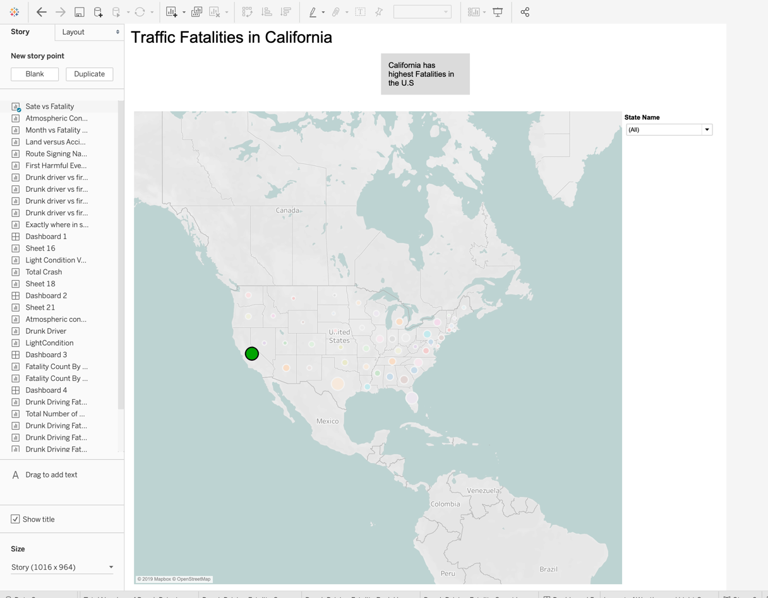

* Drag and drop the next worksheet, next to the first story caption. It will automatically create a new story point.

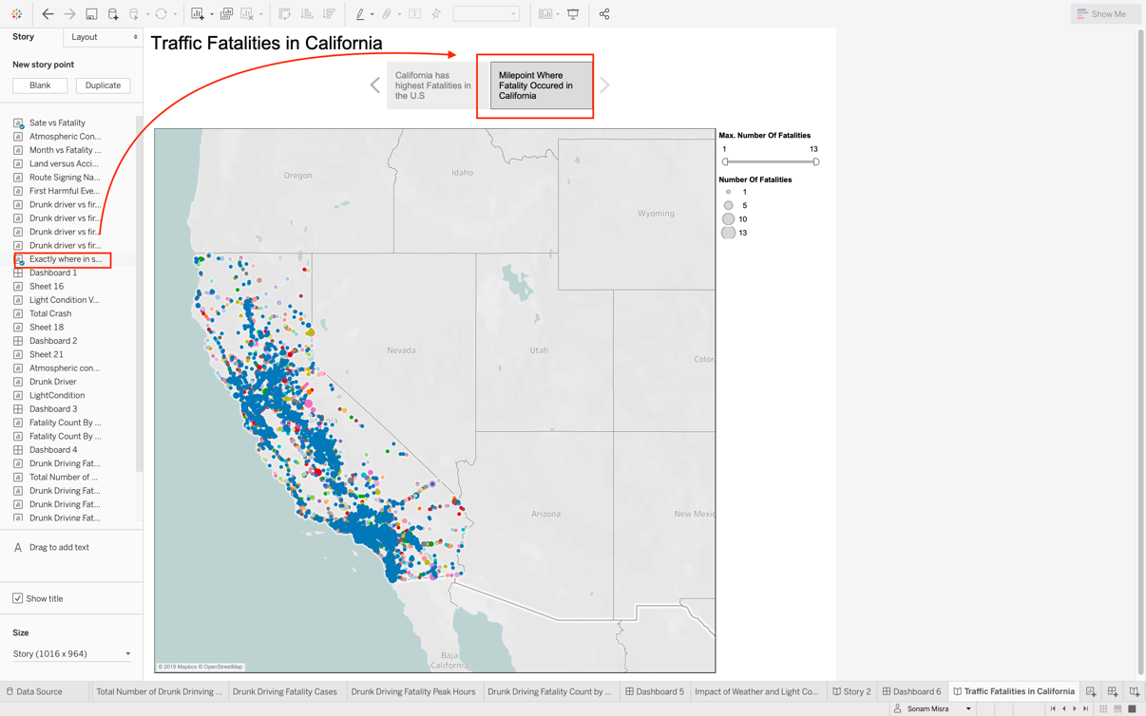

* To display the Exact Mile point with highest Fatality occurred. Drag and drop the worksheet created earlier.

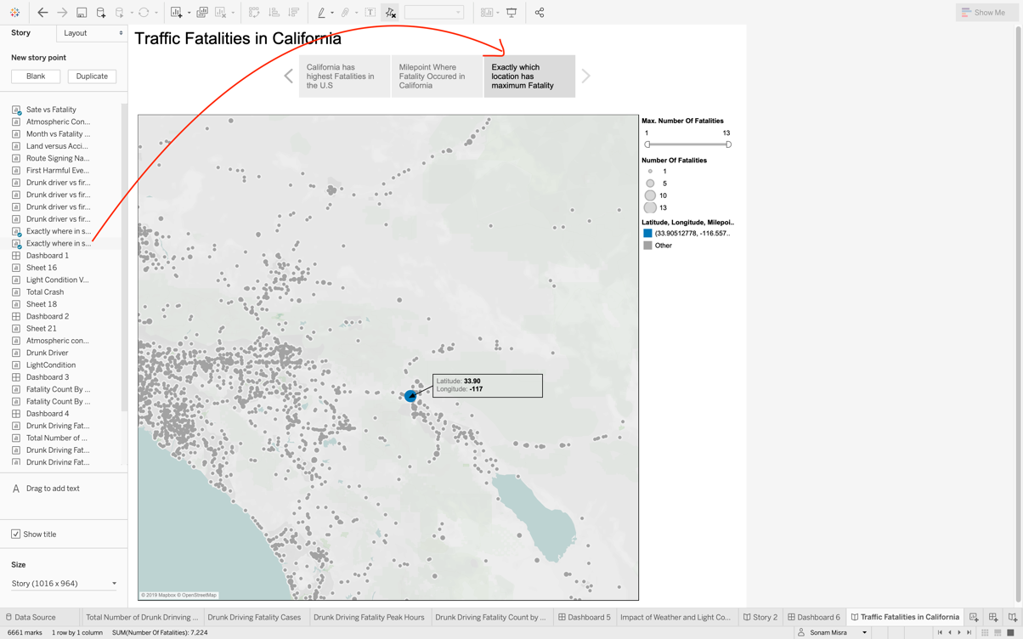

* Next drag and drop the dashboard next to the last story point you just created, to show the impact of weekdays and hours. It will make your next story point ->Give a suitable story point heading.

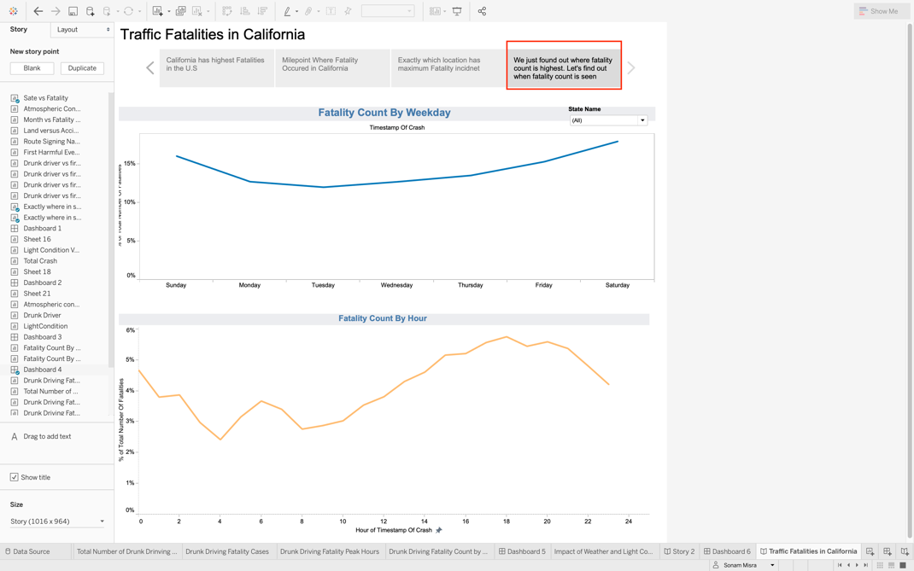

* Drag and drop the dashboard you created to show the impact of rural and urban areas as well as different type of road and give a suitable name to your story point.

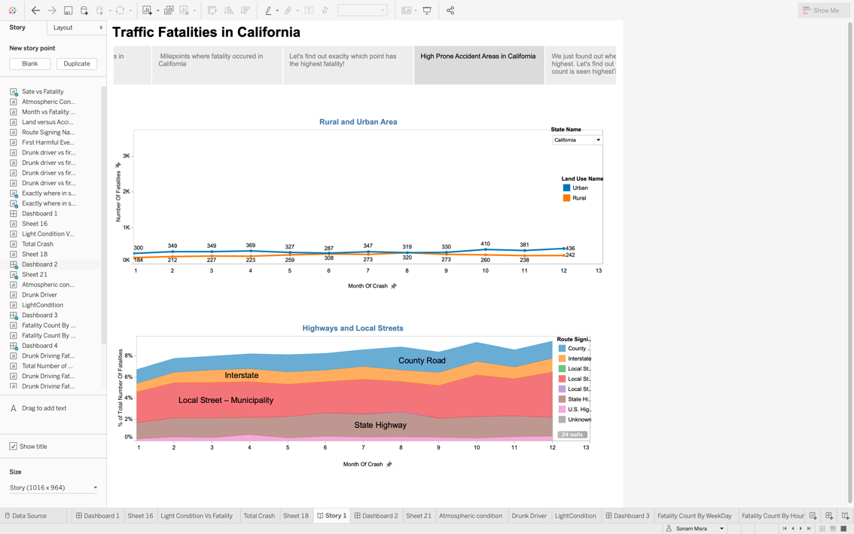

* Drag and drop the dashboard created earlier to display the impact of drunk driving, light condition and atmosphere and give a suitable story title.

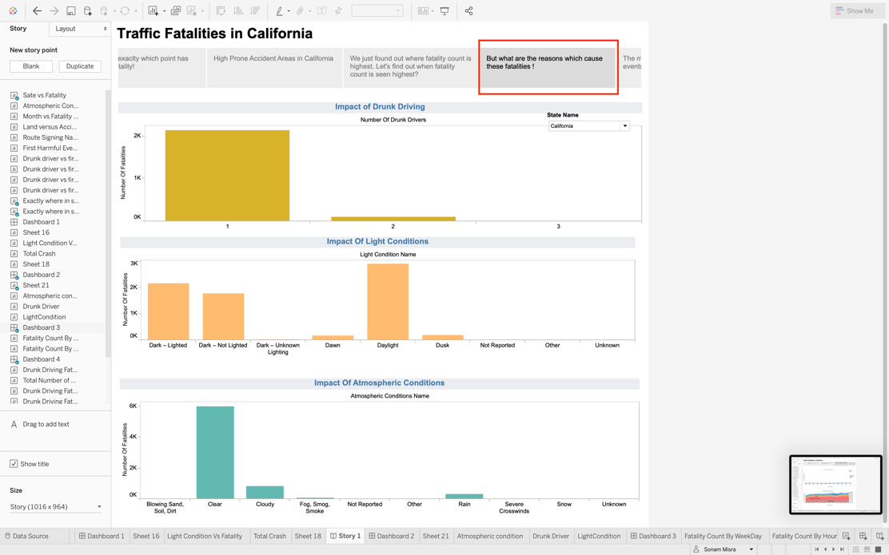

* Drag and drop the worksheet created to show the impact of different accident events.

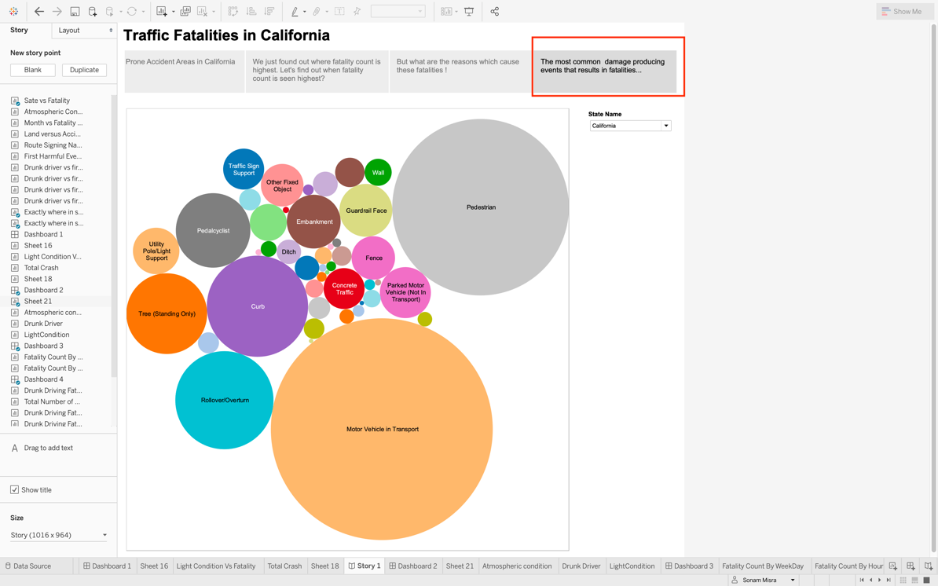

**Publish Storyboard to Tableau Public:**

Same as Dashboard

1. Results/Insights/Conclusions:
   1. Results/Insights/Conclusions (Dashboard):

From the fatality count by state tile, it is observed that three states show highest fatality count i.e. California (11.44%), Texas (10.13%) and Florida (8.66%). On comparing the statistics of top three states, below conclusion can be made.

**Findings and Conclusion**:

* It is observed that California state has the highest fatality count among top three states with a total of 3,581 accident during the period of 2015-2016 and total fatality count of 7,224. This fatality count may include the people who were in the vehicle including driver and people outside the vehicle.
* We can see that fatality count does not change rapidly over the months in case of California. It ranges between 6% to 8 %. On comparing the months for all three state, October tends to be a common month where fatality is high for all the three states. In California and Florida, December is another month with high fatality but not in case of Texas. On analyzing the months where low fatality is there, a common trend is found i.e. If the weather is clearer more accidents are there ad compared to the snowy season. That’s why Texas has less traffic fatalities in December as the snow and fog is more and maybe less people travel by car which results in less accidents.
* It is observed that most of the accidents happened during daytime followed by dark light and dark not lighted conditions for all the three states. Most of the fatalities happened on Clear days followed by rainy days.
* Urban areas met most of the accidents as compared to rural areas in all the three cases. It is may be because of the higher population in the urban areas.
* Some outliers were detected while analyzing the monthly fatality data. In month of August Wyoming reported 19% fatality. The reason for this need to be investigated separately.

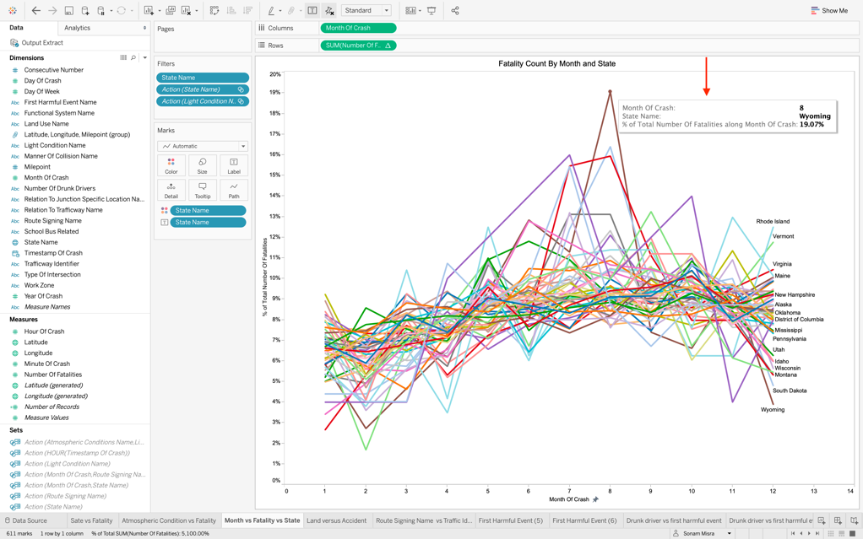

**Recommendations:**

* Security measures have to be improved in urban areas. More strict laws need to be implemented in highly populated areas.
* Highways, county Roads, Interstate highways and other routes should be well lighted as poor lighting is a common issue for traffic fatalities.
* Security force and drivers should be vigilant on rainy days.

**Dashboard** **presenting KPIs for California**:

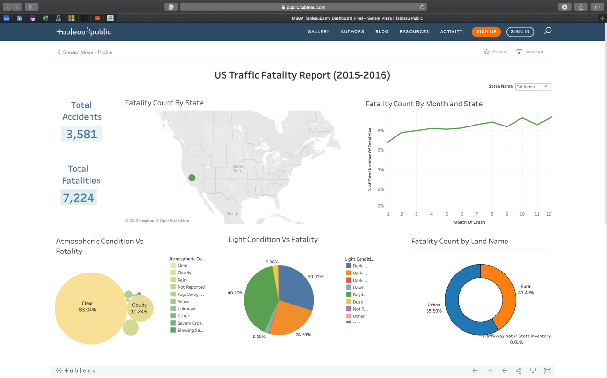

**Dashboard** **presenting KPIs for Florida**:

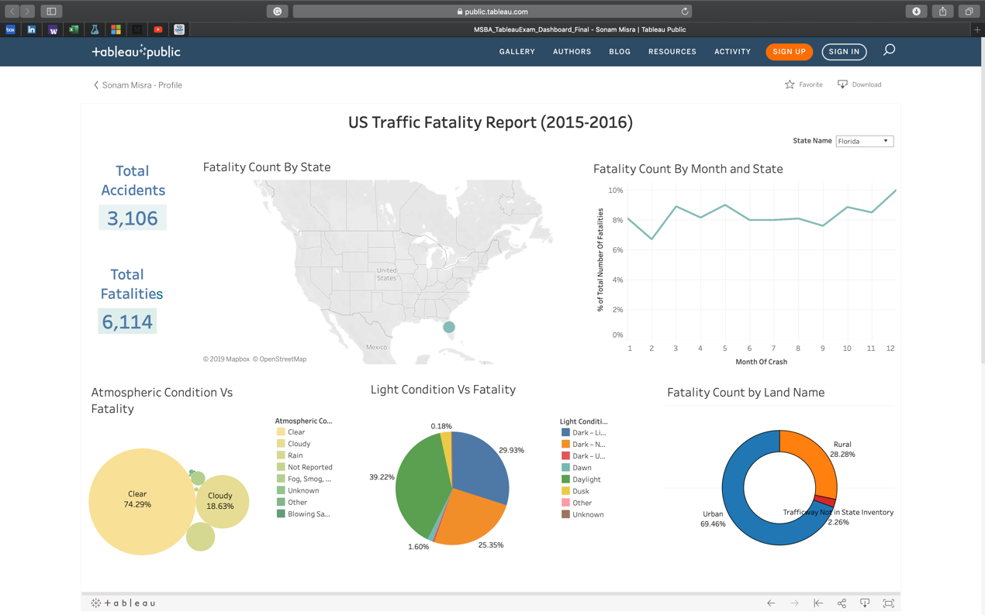

**Dashboard presenting KPIs for Texas**:

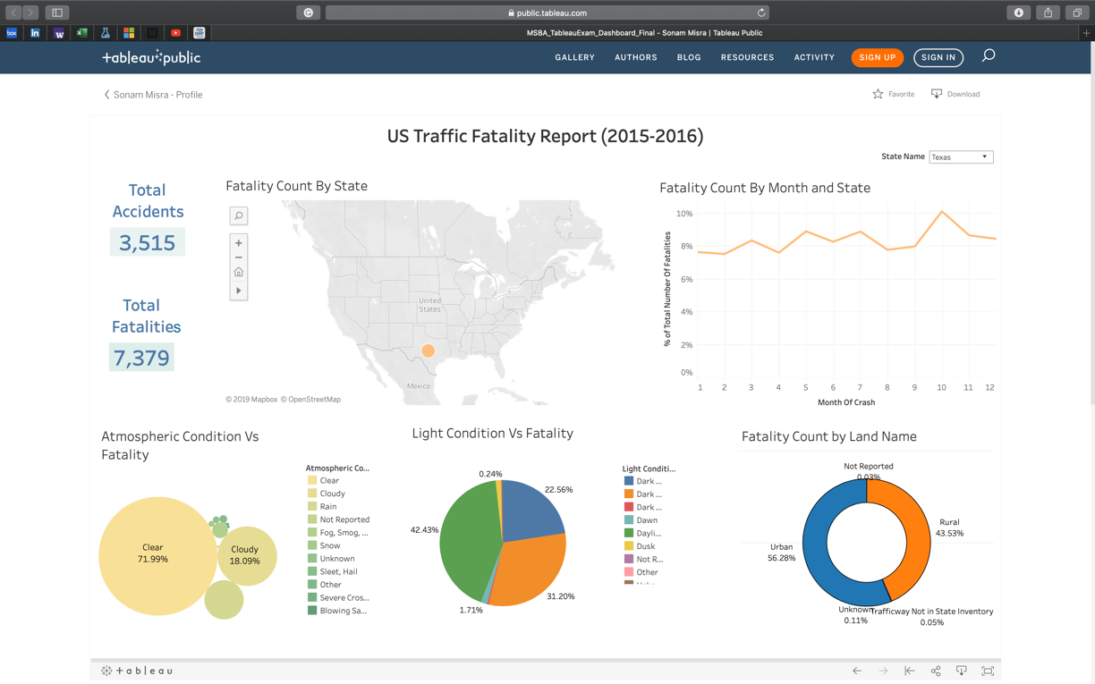

* 1. Results/Insights/Conclusions (Storyboard):

California is identified as the state with highest road fatality incidents for the year 2015-2016.

* There are multiple mile points identified which had fatality incident during these two years in California.
* On filtering these mile points, there is one-mile point 325, latitude 33.90 and longitude -117 which has the maximum incidents. Thirteen incidents at the same exact mile point.
* On analyzing the road and highways, it is found that local street in California has maximum reports followed by state highway and County Road.
* Rural and Urban areas did not see much difference. Urban areas have slightly more fatality reports as compared to rural areas in California.
* Weekends has most of the fatality incidents.
* Midnight and evening time from 6 to 8 are peak hours for road fatalities.
* Most of the road fatalities are caused by motor vehicles in transport followed by the pedestrian and rollover/overturn.

**Recommendations**:

* Location: mile point 325, latitude 33.90 and longitude -117 should be analyzed and issues need to be fixed as this exact point had maximum fatalities (i.e 13 fatalities in 2 years)
* More security force or some new regulations is needed is needed on Saturday and Sundays; and on daily basis at midnight and evening time.
  1. Innovative Solution:

An application which uses advanced analytics and is based on real time predications can control traffic fatality situation. The app should be able to predict the chances of fatality in a particular location by monitoring the real time traffic data, road conditions, weather condition and past incidents. This app should be able to automatically send alerts whenever person is close to the dangerous location or event.

1. Learning Objectives (Measure):

* Implement interactive visualizations to explore the US traffic fatalities data from different angles.
* Understand the characteristics of environmental factors, trafficways, Collison nature and impairment due to alcohol and their impact on traffic fatalities.
* Identify the relationships, outliers and trends present in the data.
* Present the insights in an optimal and engaging way.

|  |  |  |
| --- | --- | --- |
| Learning Objective | Activities/Tasks | How would you measure the reader’s learning? |
| Able to find out total number of fatalities in each state. | Plot the chart between road fatality and state and present using appropriate chart for location. | If the student is able to present the below the chart, he fulfills the learning objective. |
| Understand the characteristics of environmental factors, trafficways, collision nature and impairment due to alcohol and their impact on road fatalities. | Plot the charts between road fatality and fields related to environmental factors, trafficways, collision nature and impairment due to alcohol and review the relationship. | Student should be able to plot three different visualization for environmental factors, trafficways, collision nature and impairment due to alcohol and review the relationship. |
| Identify relationships, outliers and trends present in data. | Plot different visualization by taking into consideration multiple fields. Review the relationship between those fields. Also, while plotting graphs, detect if there are any patterns present in the data and if there are some values which lie outside those patterns. | If the student is able to make charts using multiple fields and present multiple scenarios from one chart by using different filters on different fields. Also, student should be able to present outliers which deviate from the normal cases. If the student can create below two visualization, he will be successful in understanding outliers and relationships.  For Relationship:    For Outlier: |
| Present the insights in an optimal and engaging way | After exploring the data from different perspectives, gather the appropriate findings which answers the research question and integrate into dashboard and storyboard. | If the student is able to create an interactive dashboard which can be understood in less than 30s and s storyboard which shows a relevant investigation of an issue, they will meet the learning objective. |

1. Limitations:

* Data of two year 2015-2016 is combined and the interpretation is based on the aggregated data.
* Data belongs to past year (2015-2016). The interpretation may not be relevant to the current time period i.e. 2019
* Data was static data that’s why the interpretation is not applicable for real time analysis. However, provided with continuous stream of data, better prediction and analysis can be done.

1. References .

* Sample documents provided by Professor